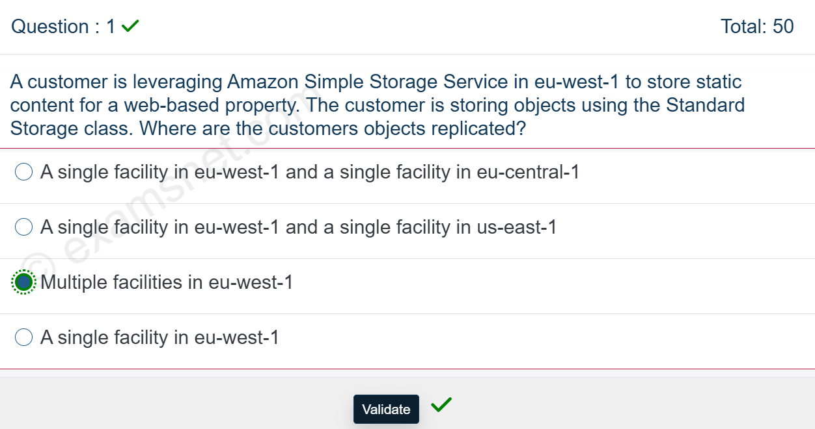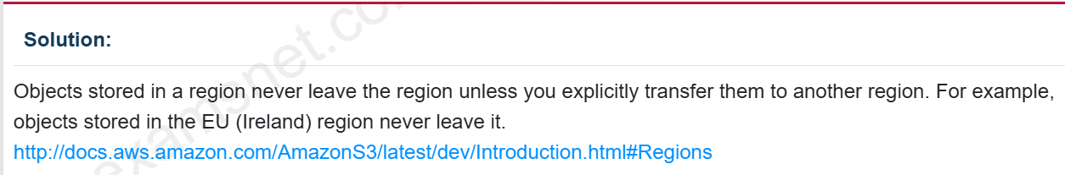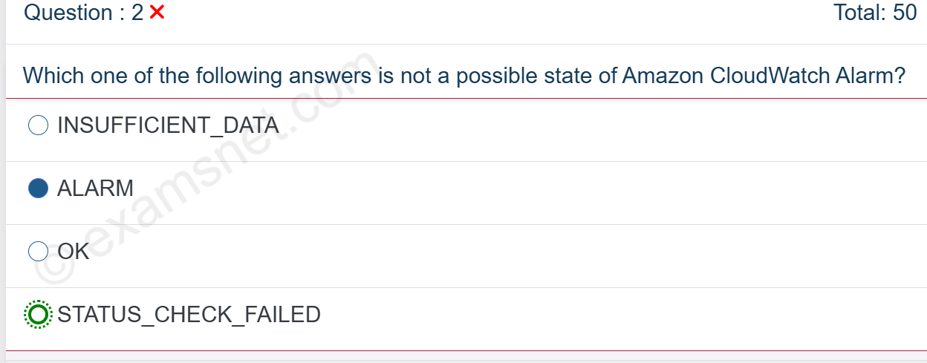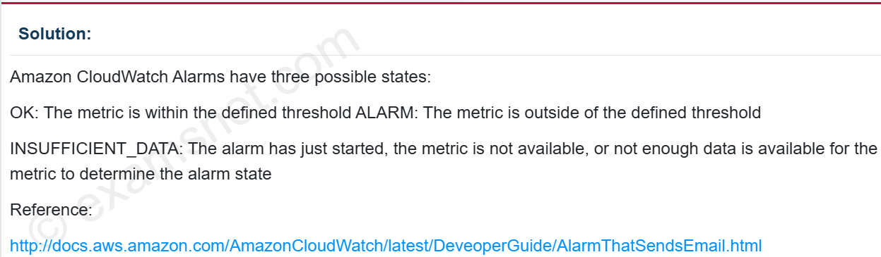

Question : 3

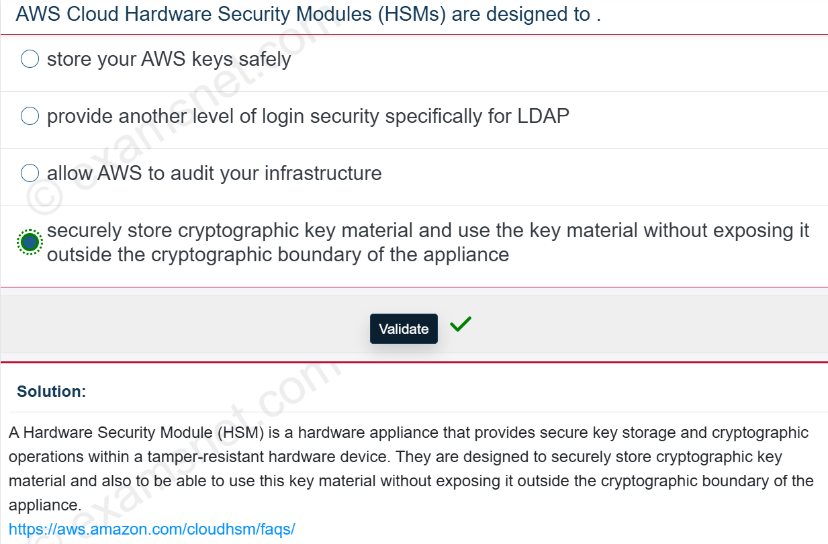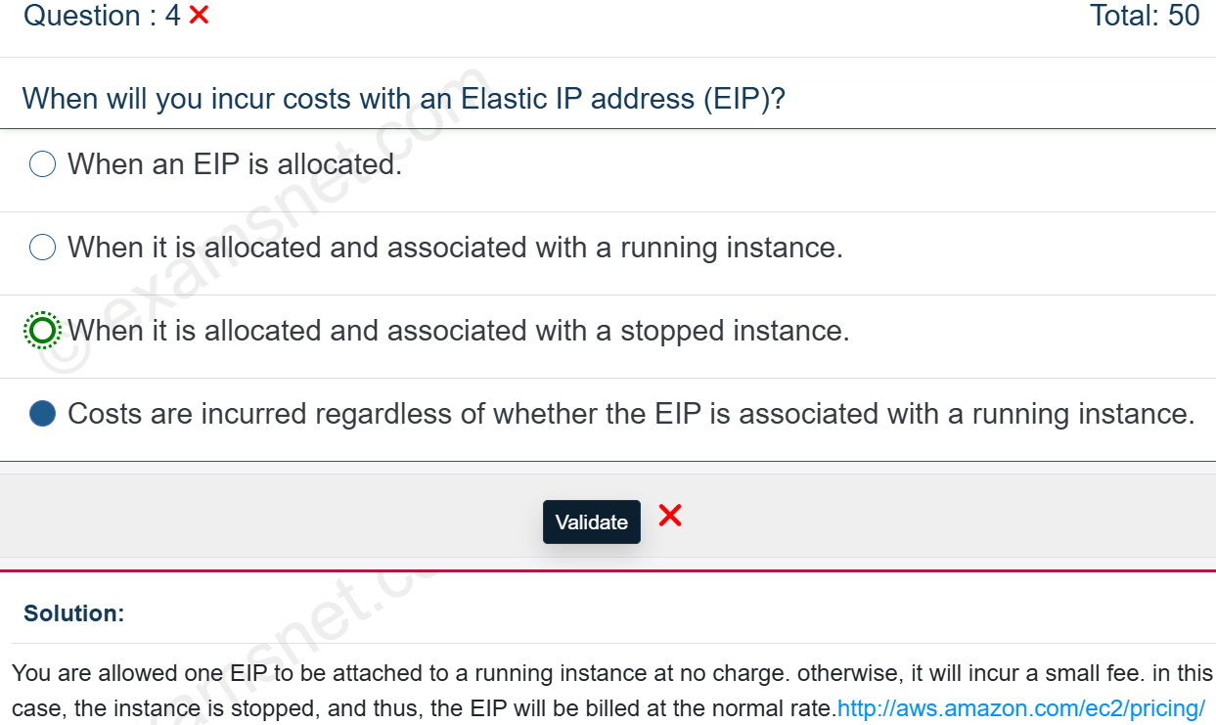

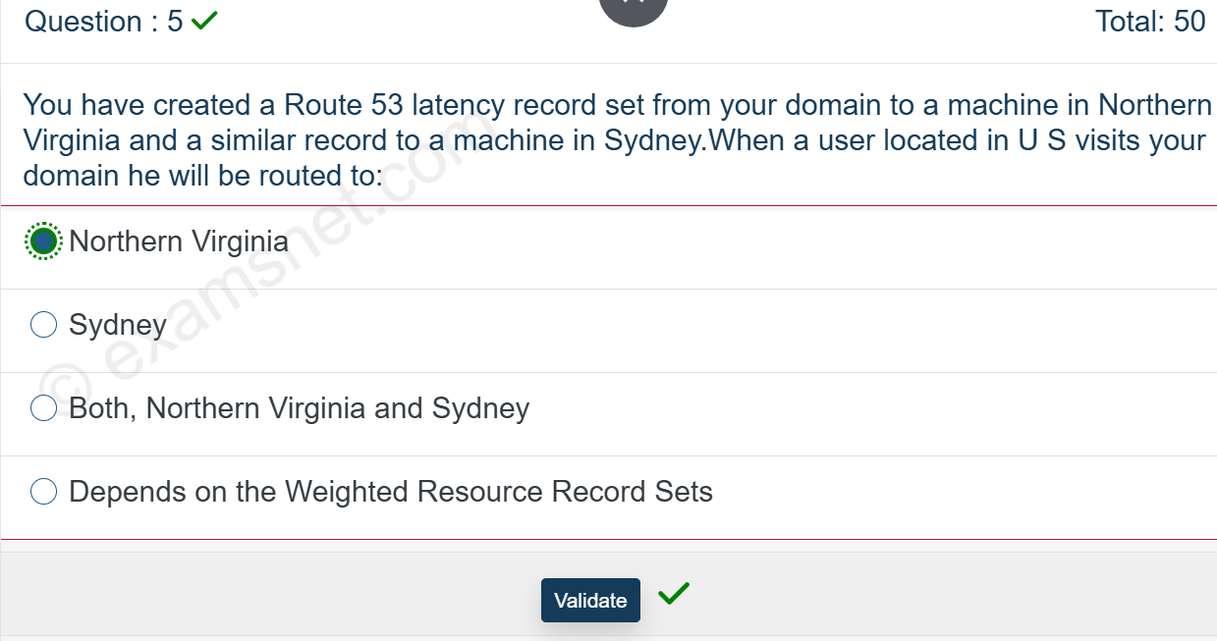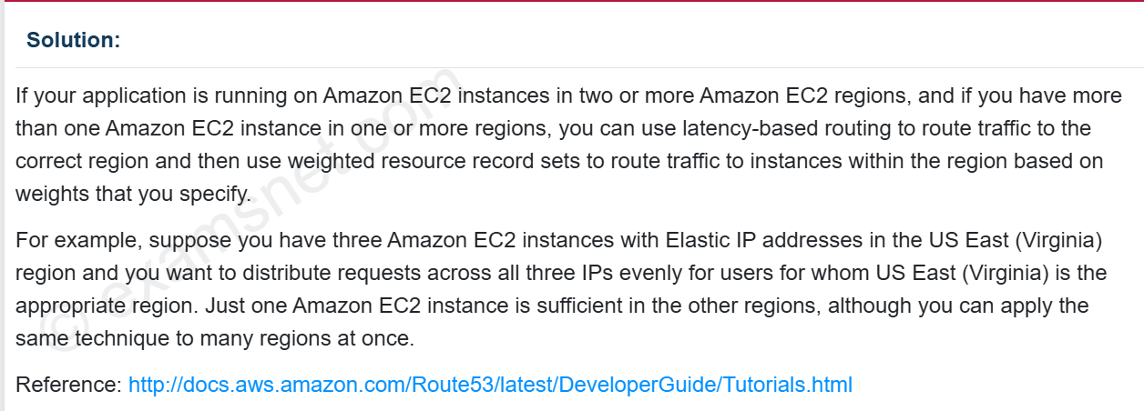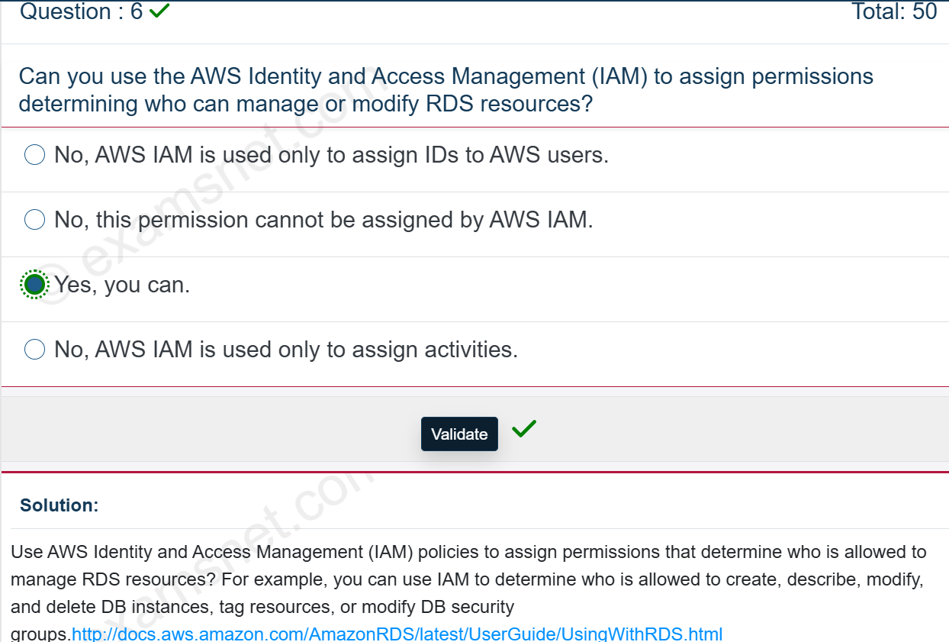

Question : 7

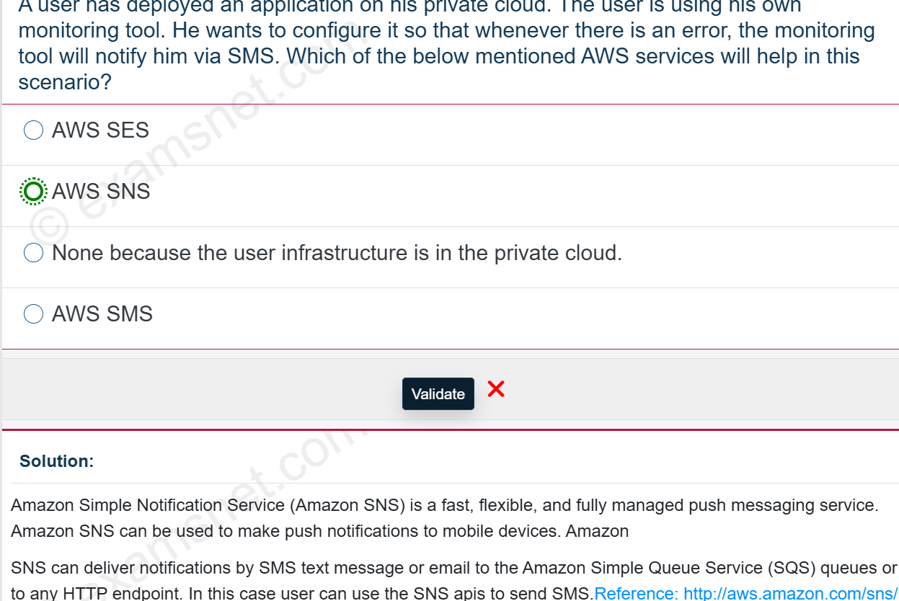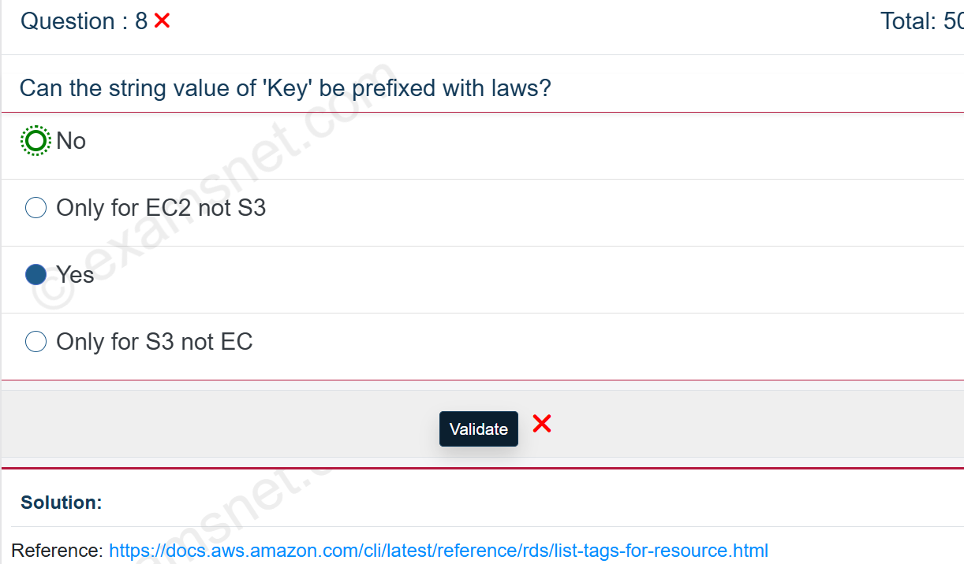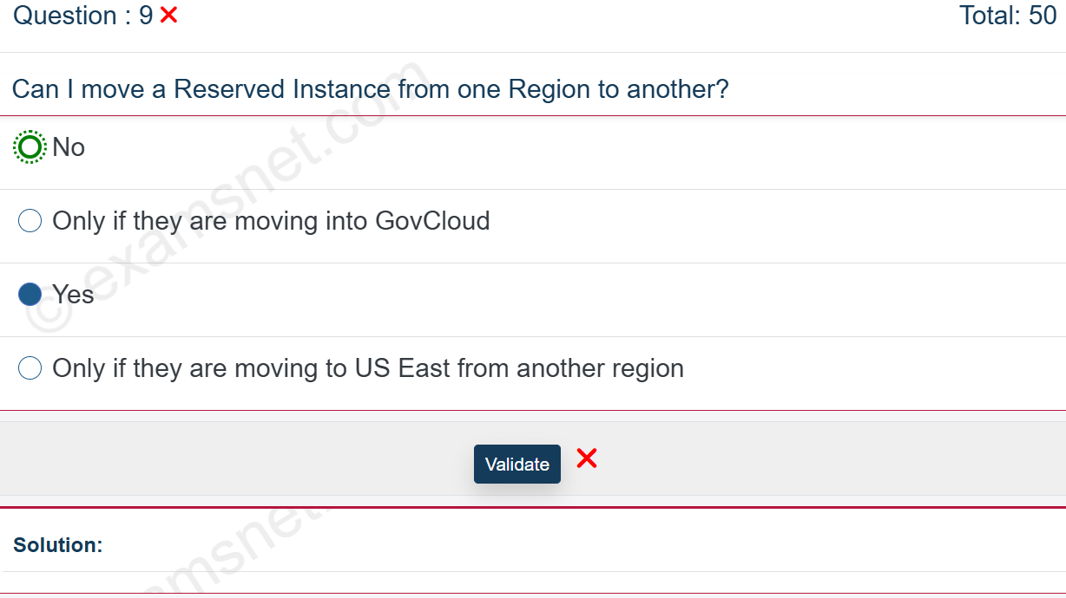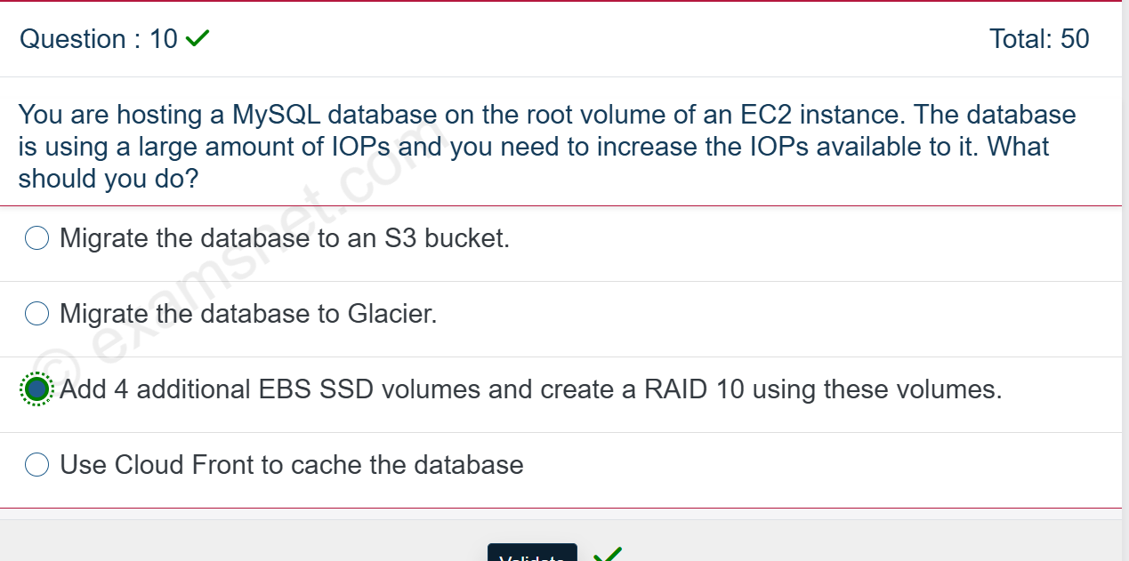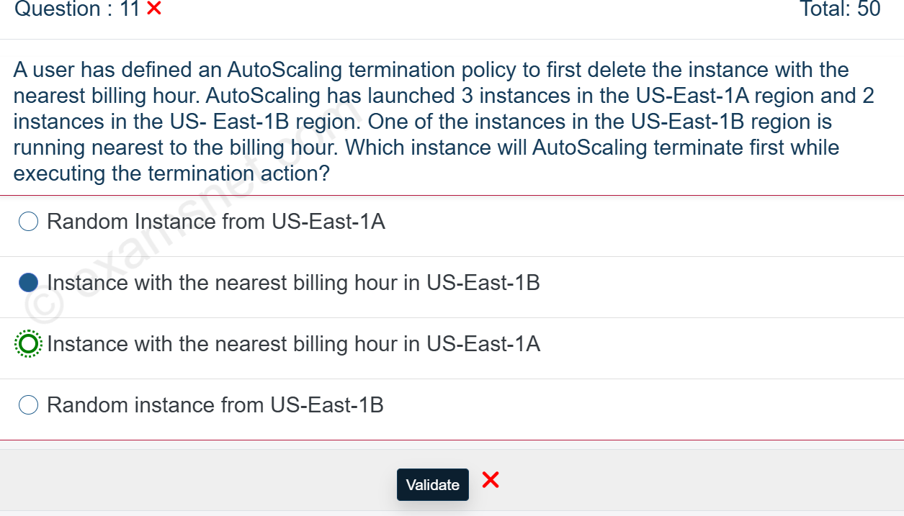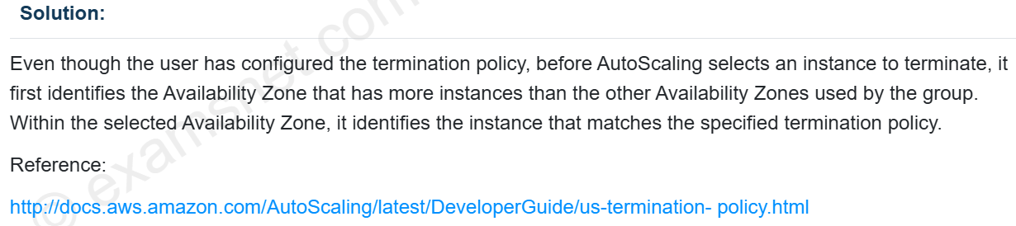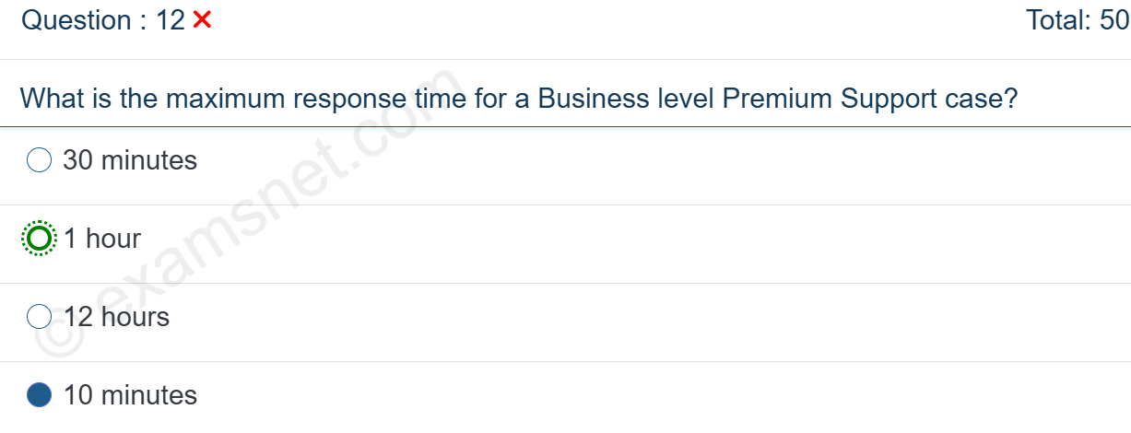

Question : 13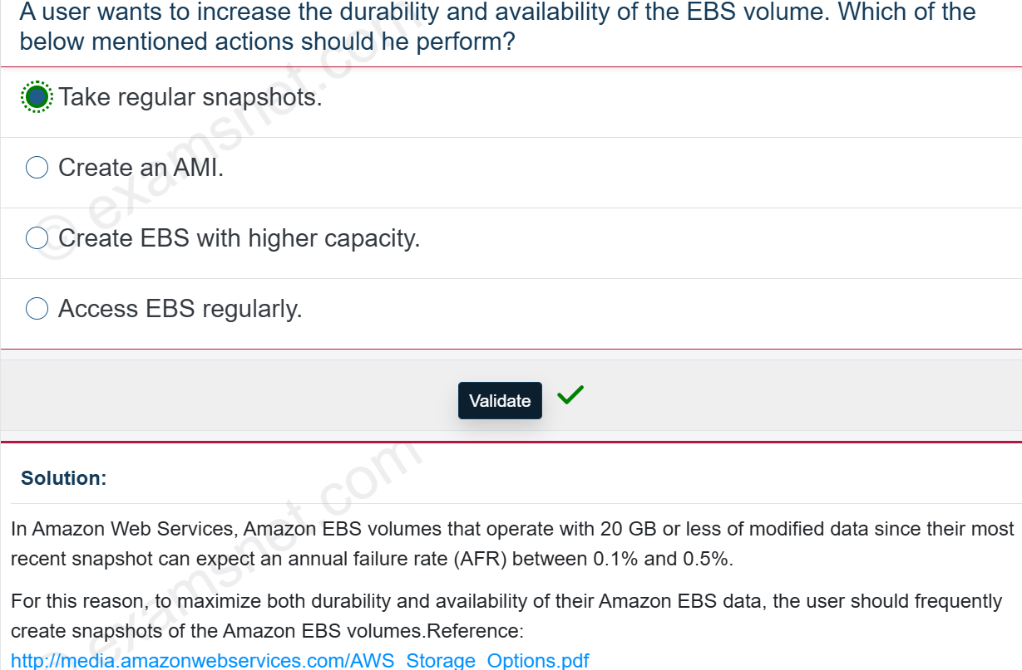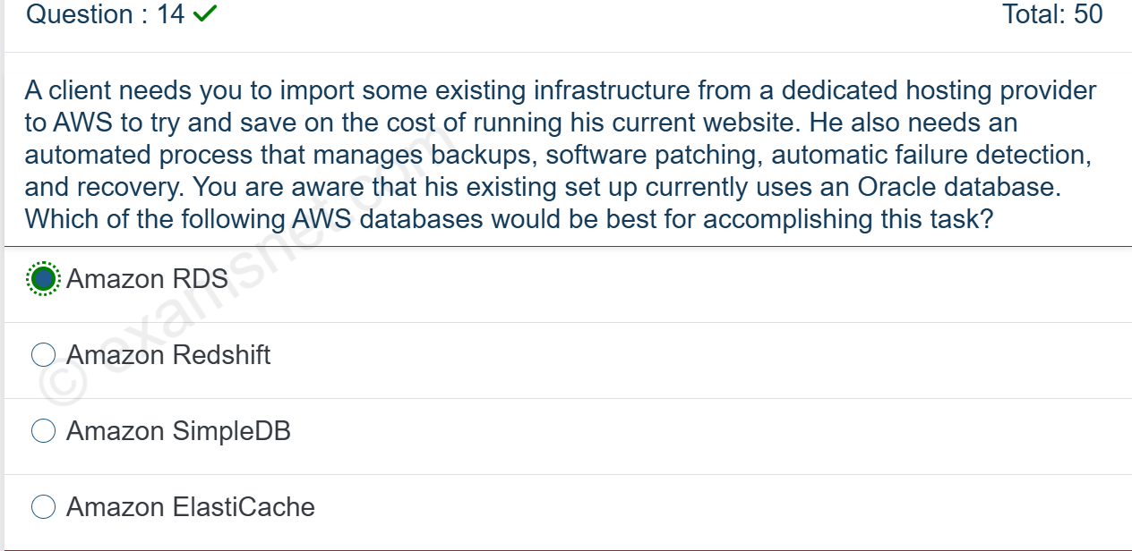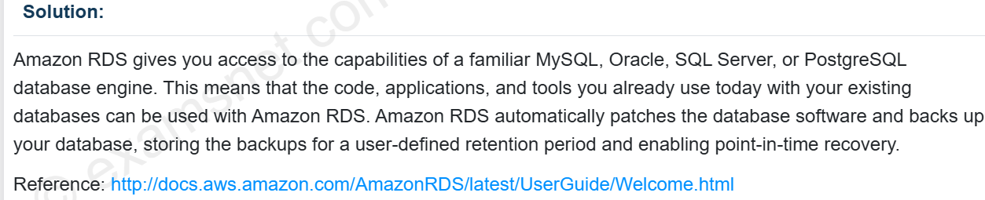

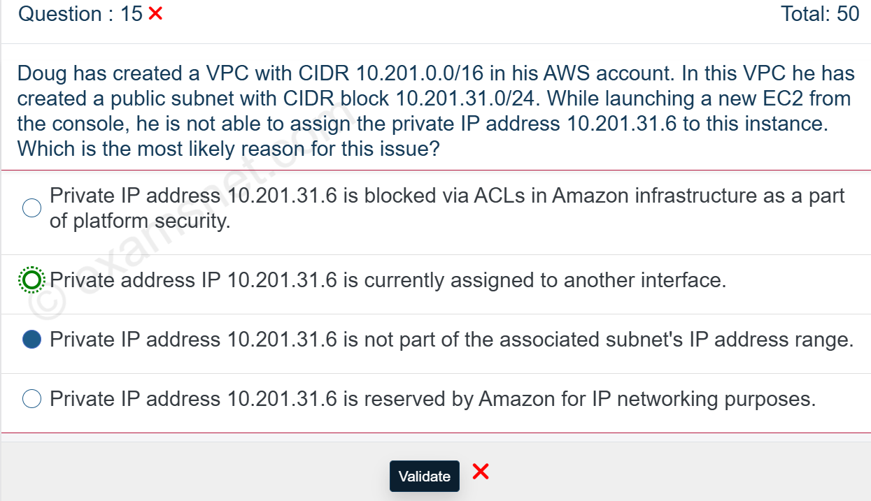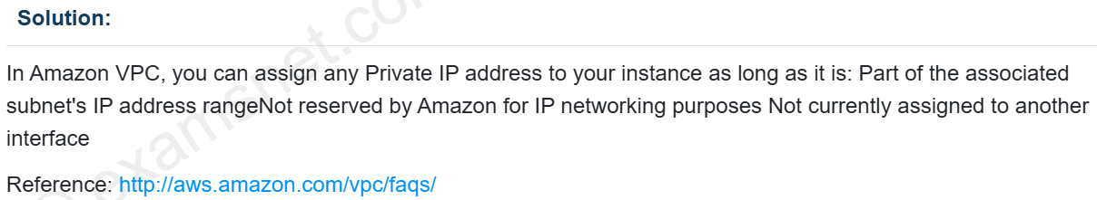

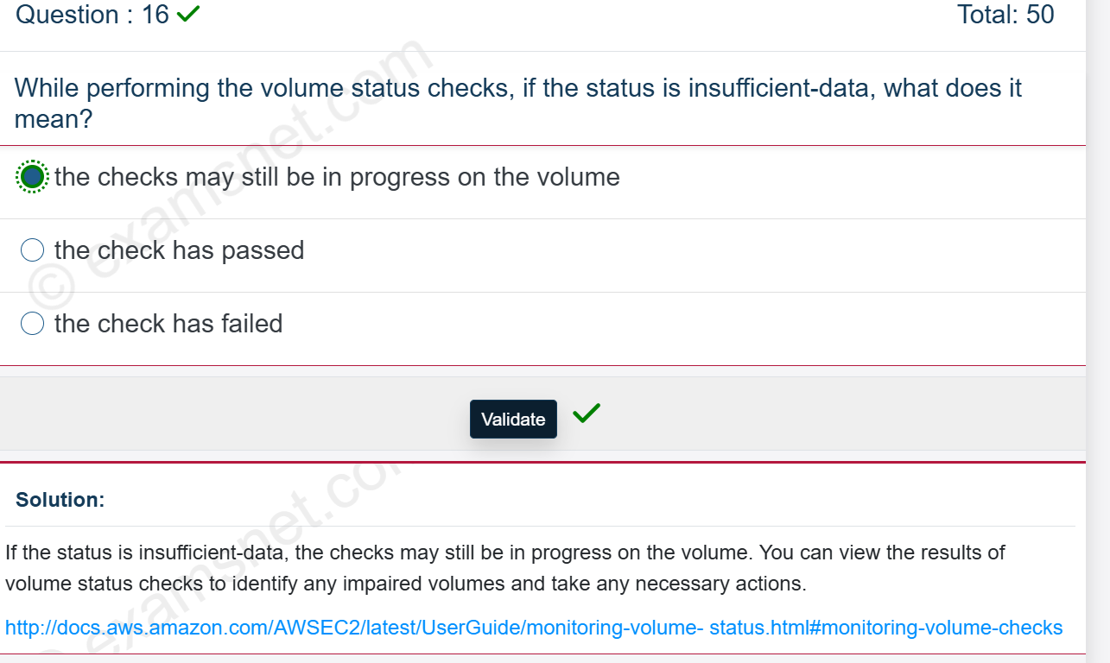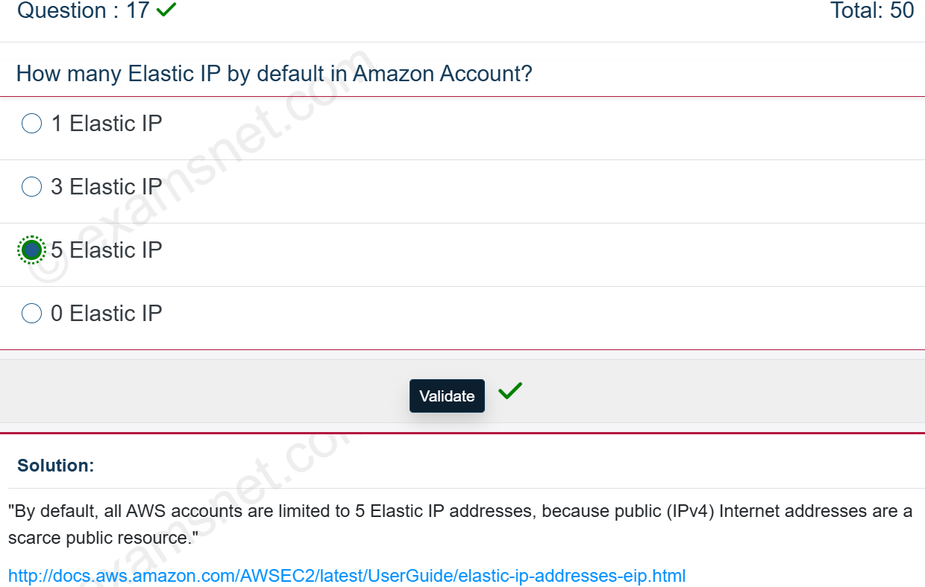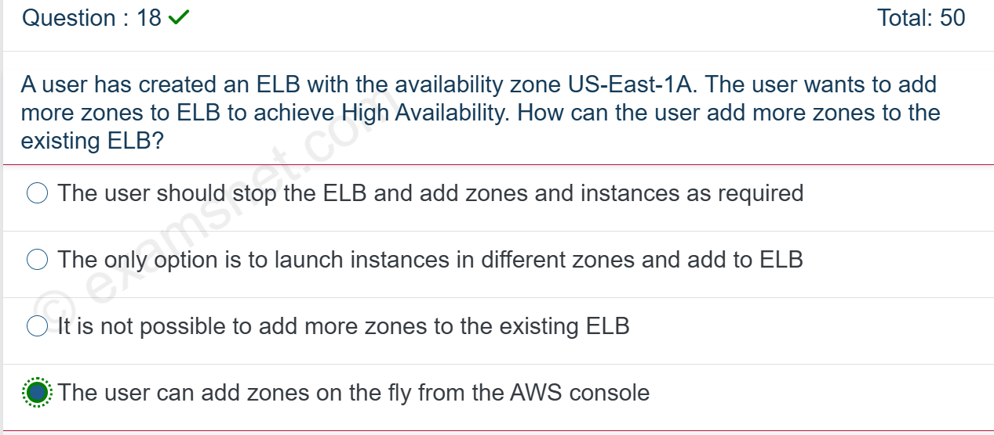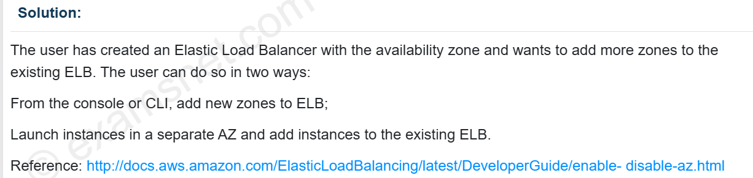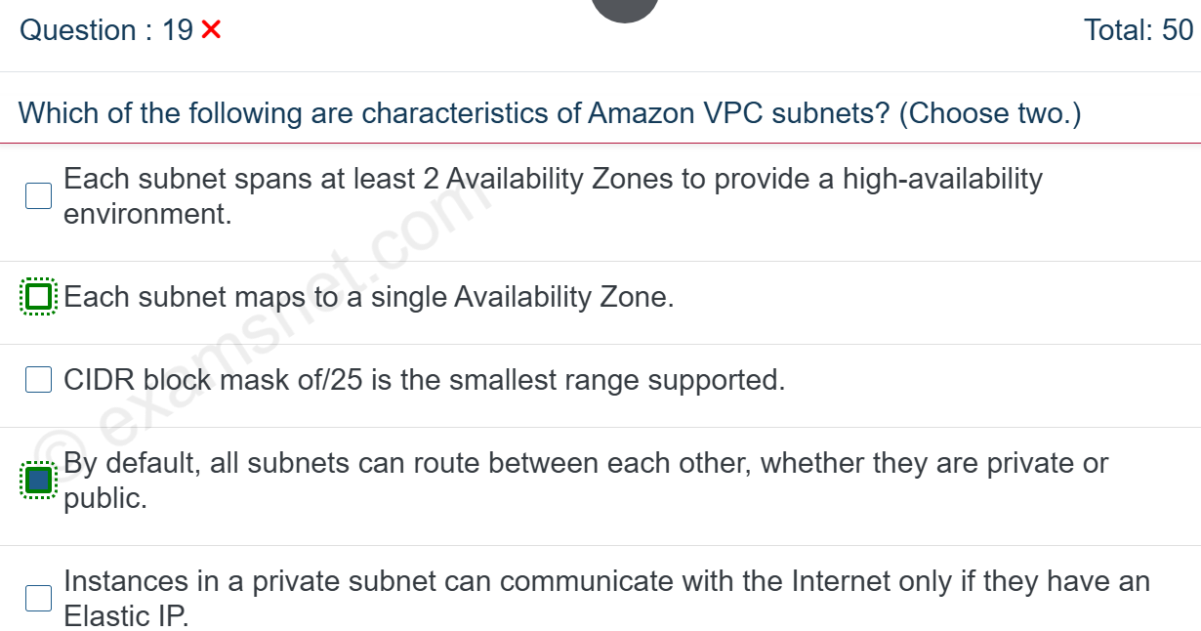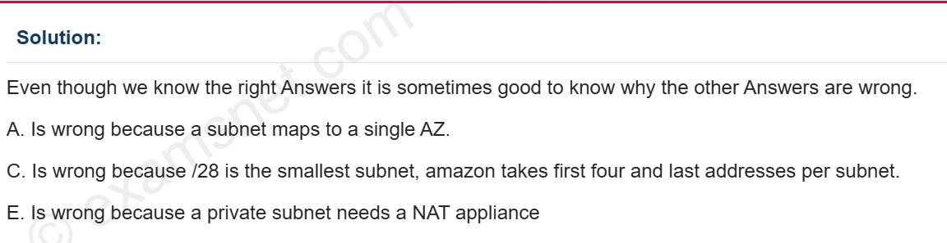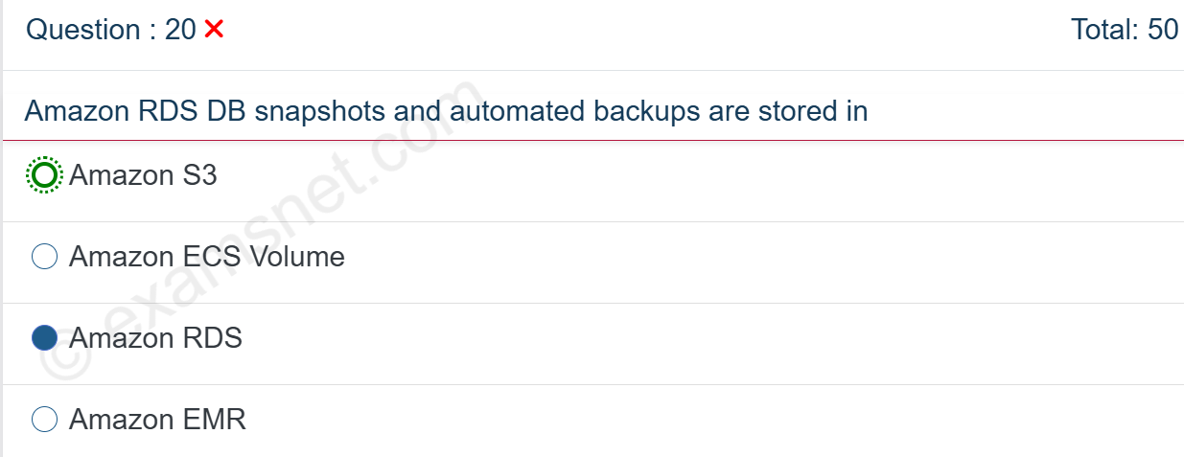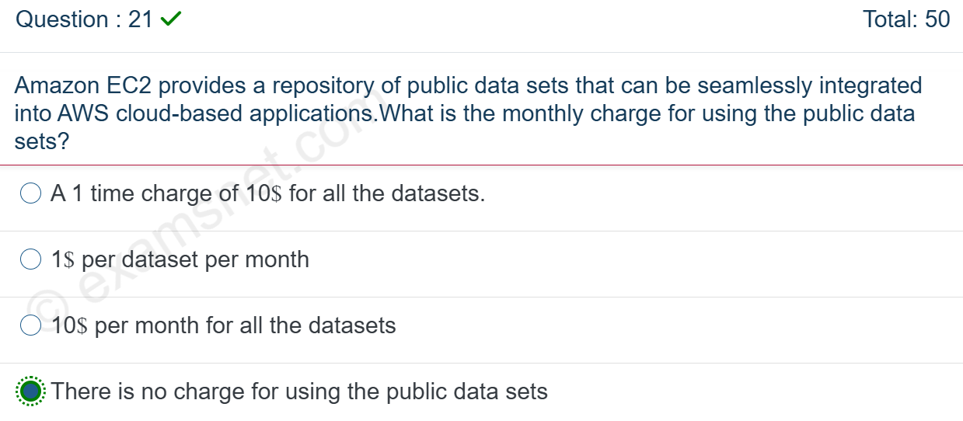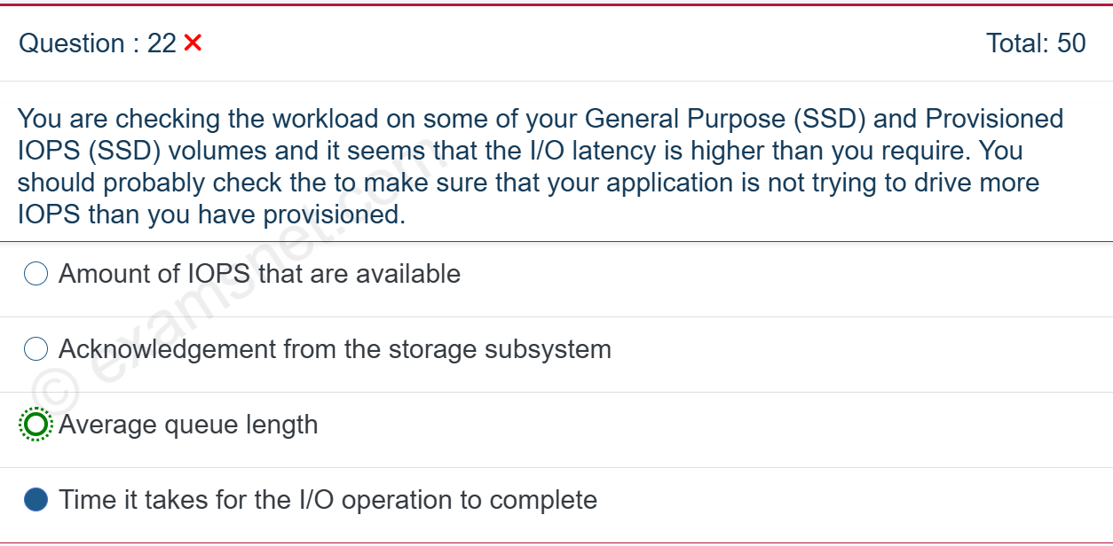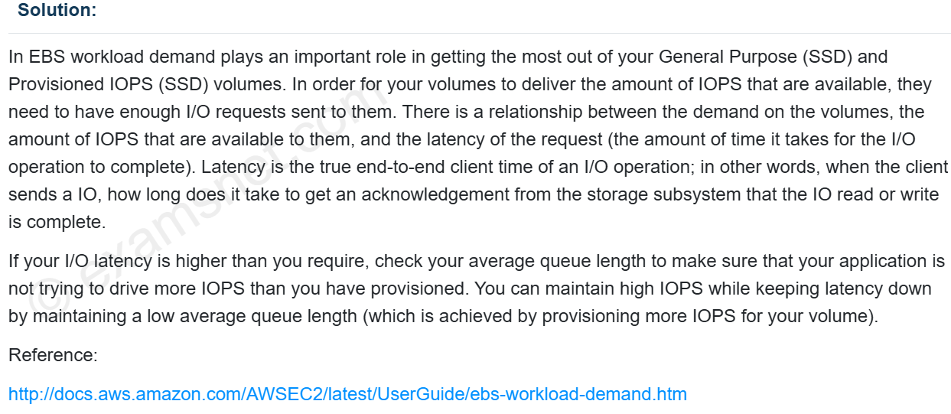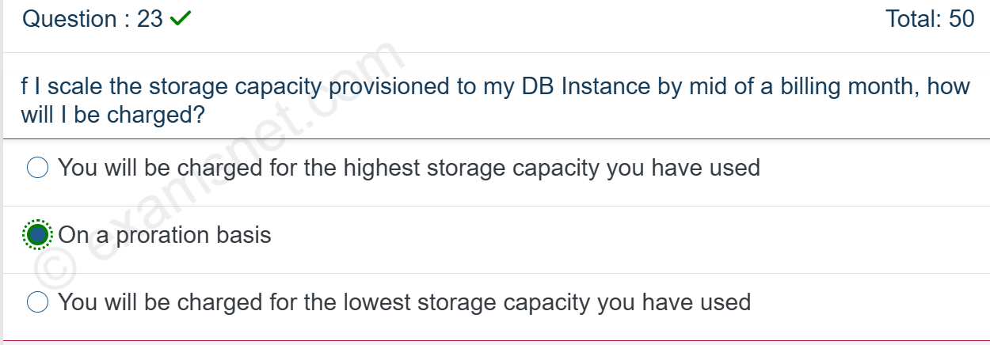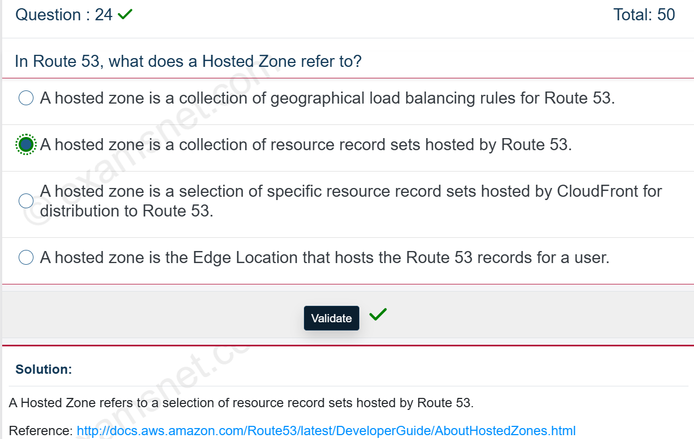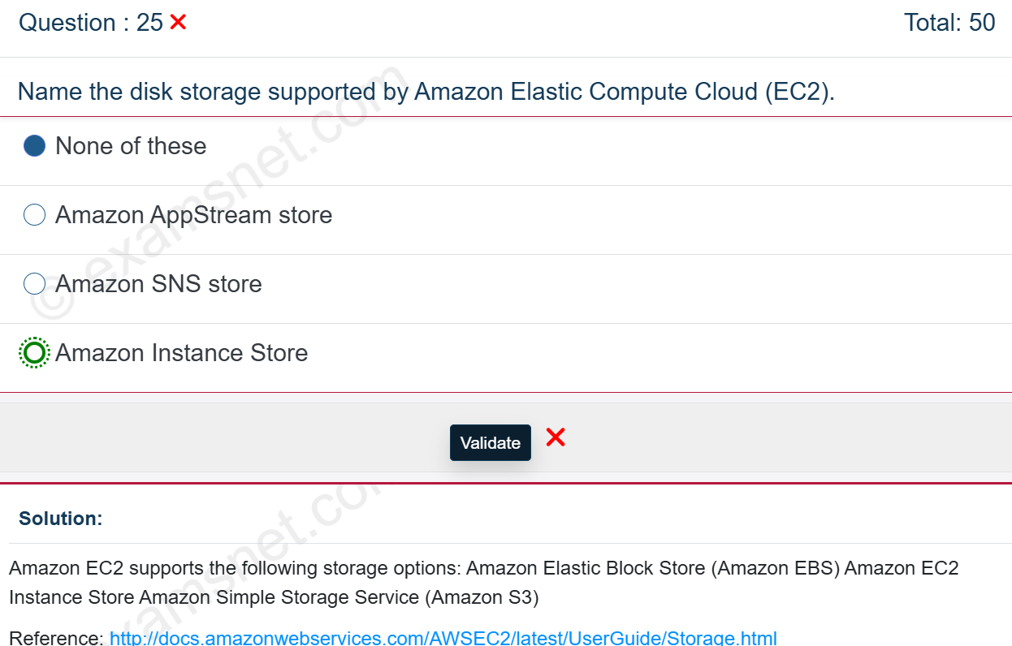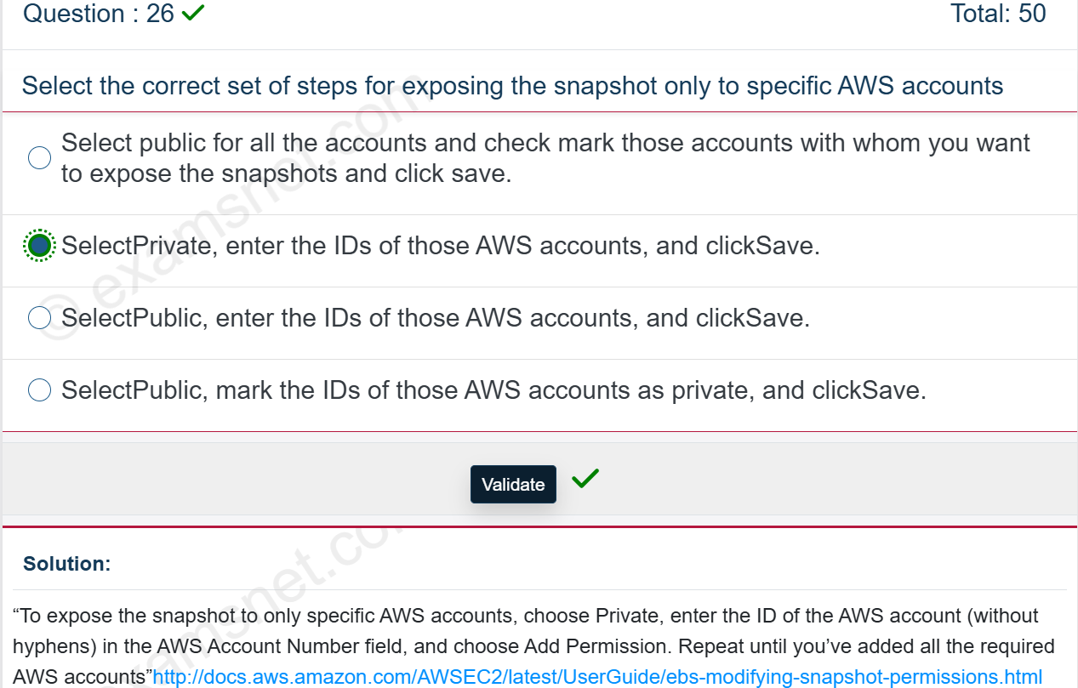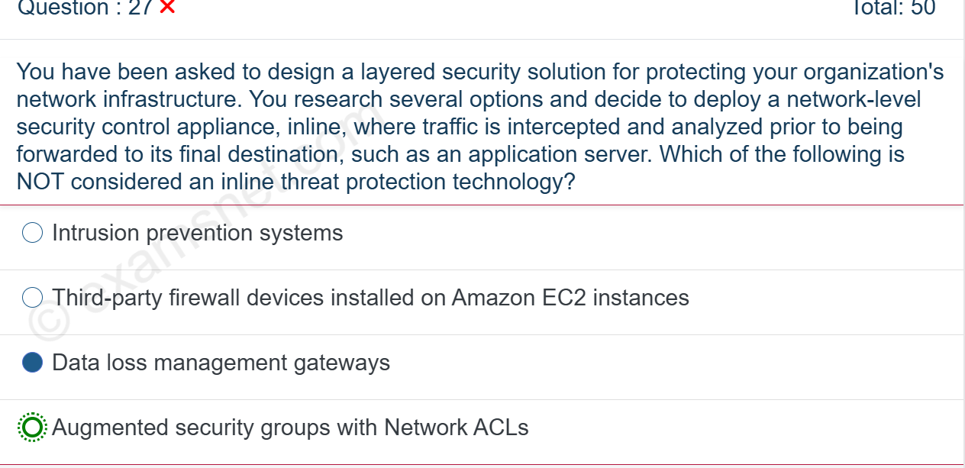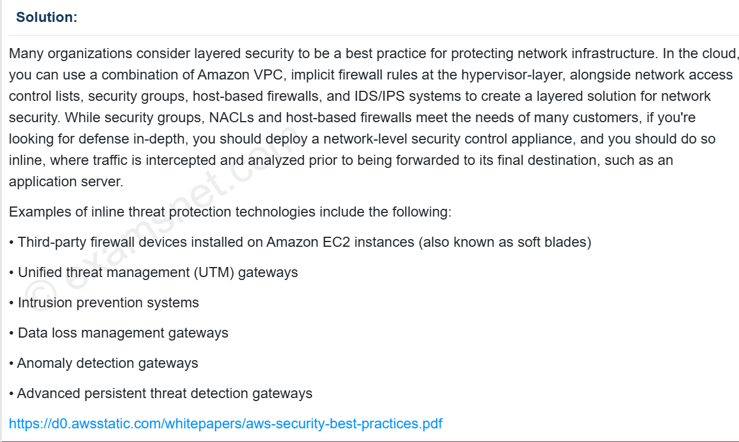 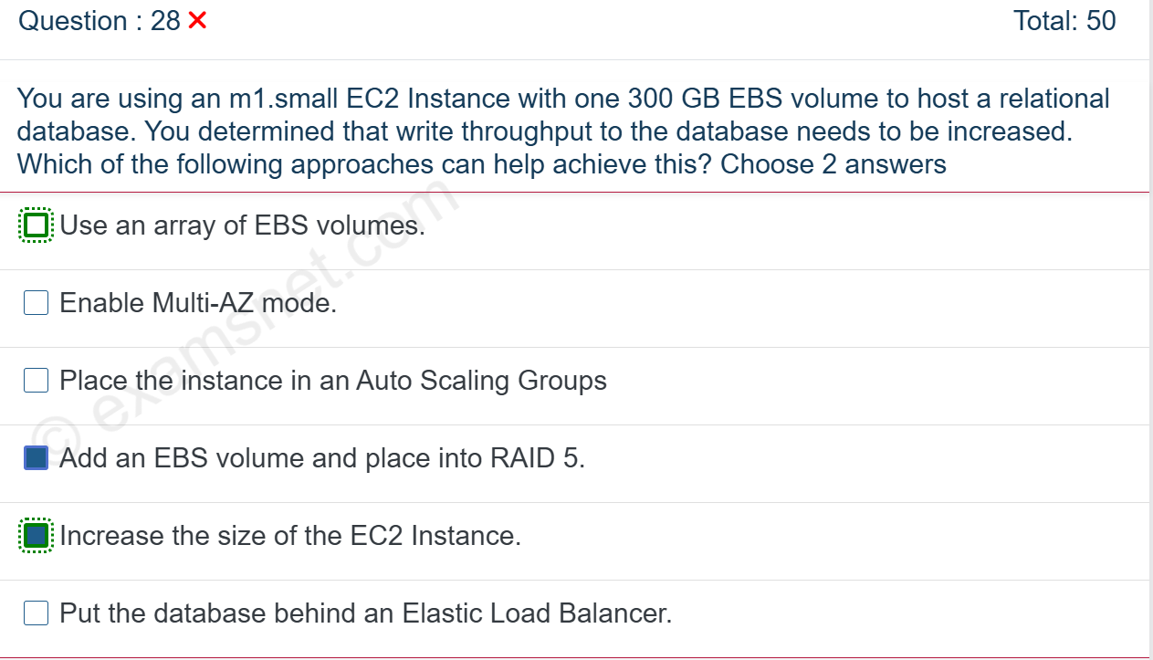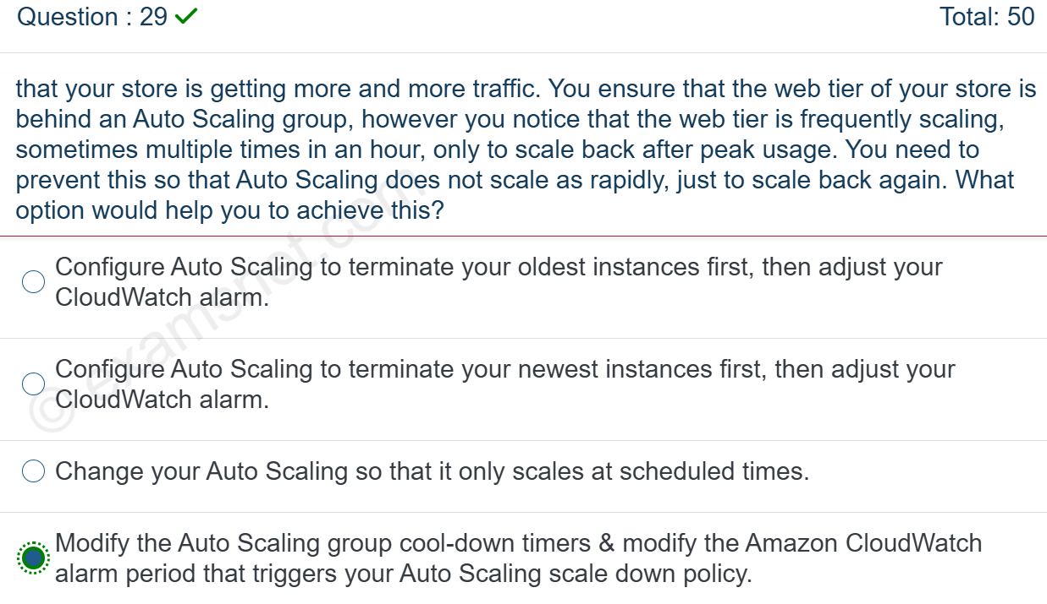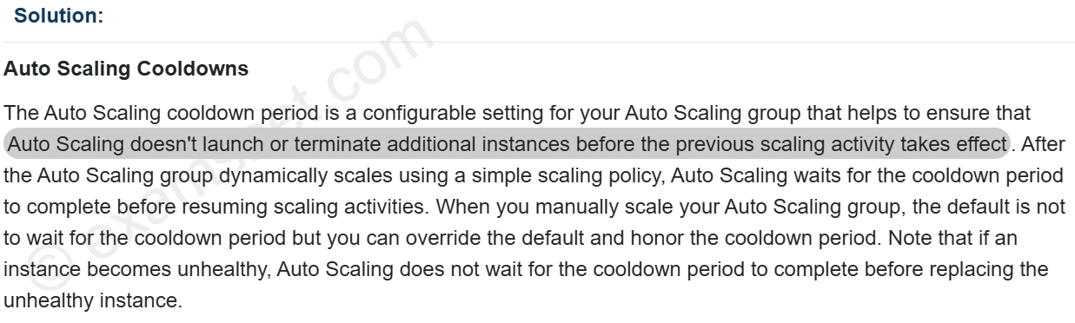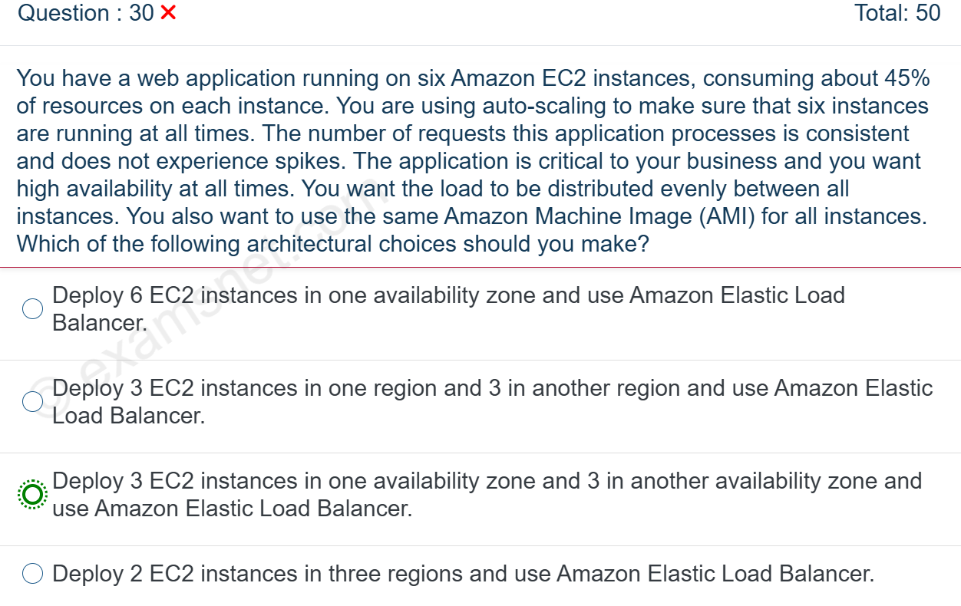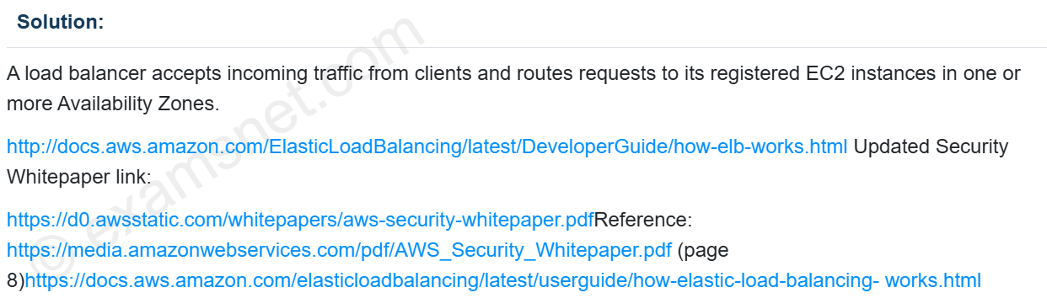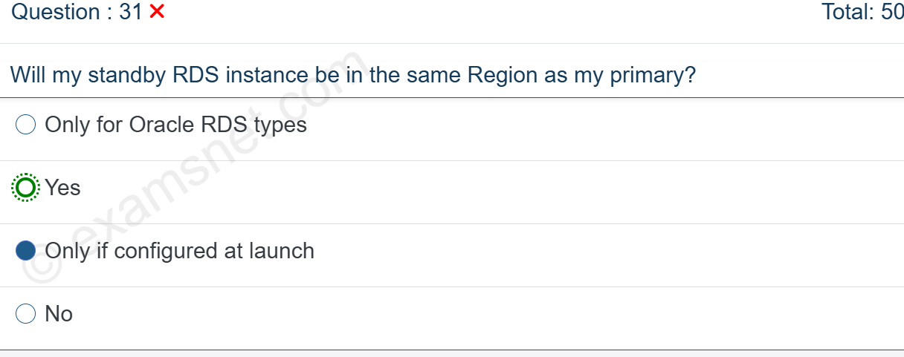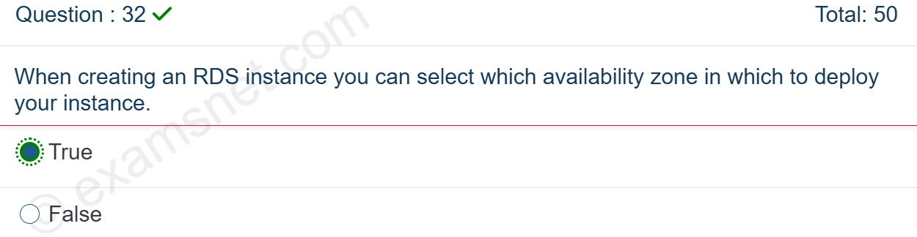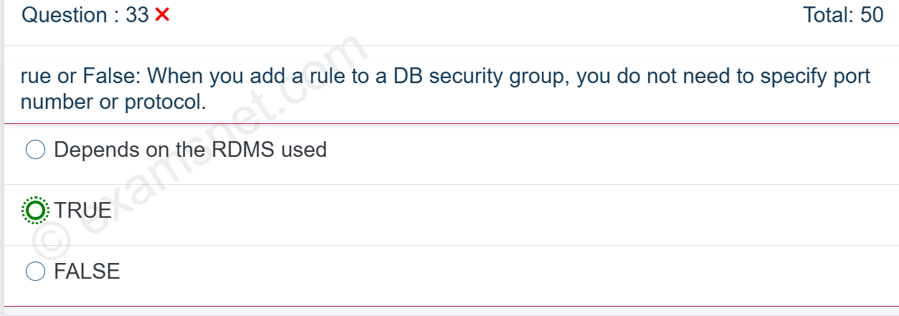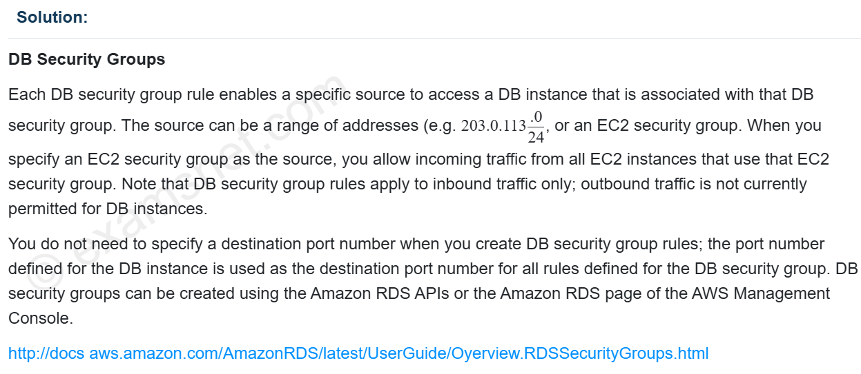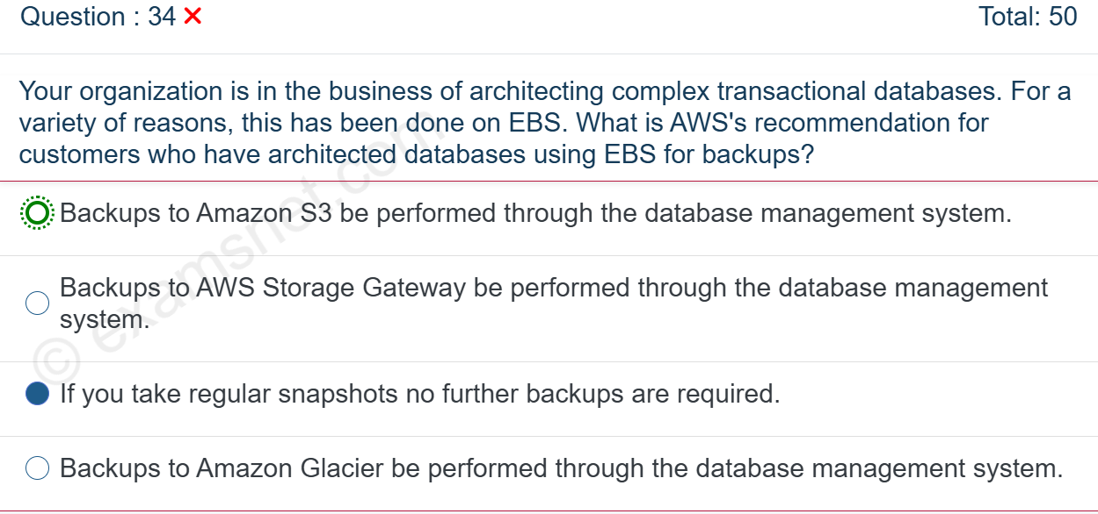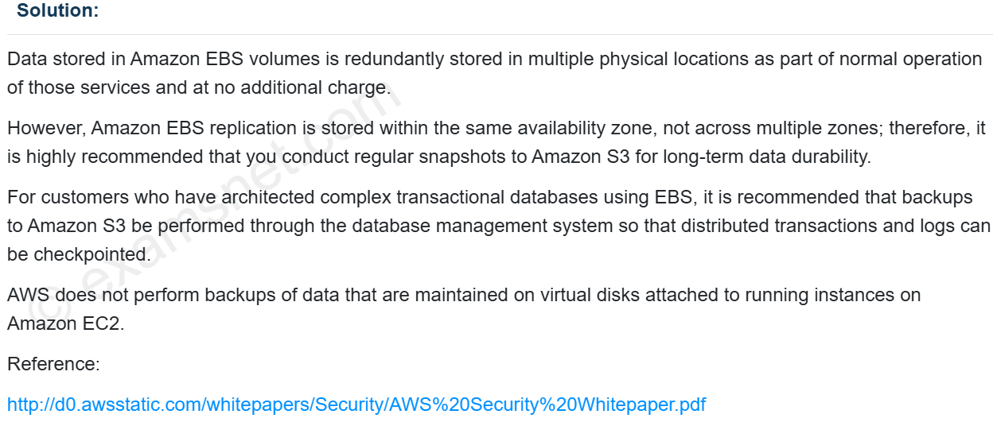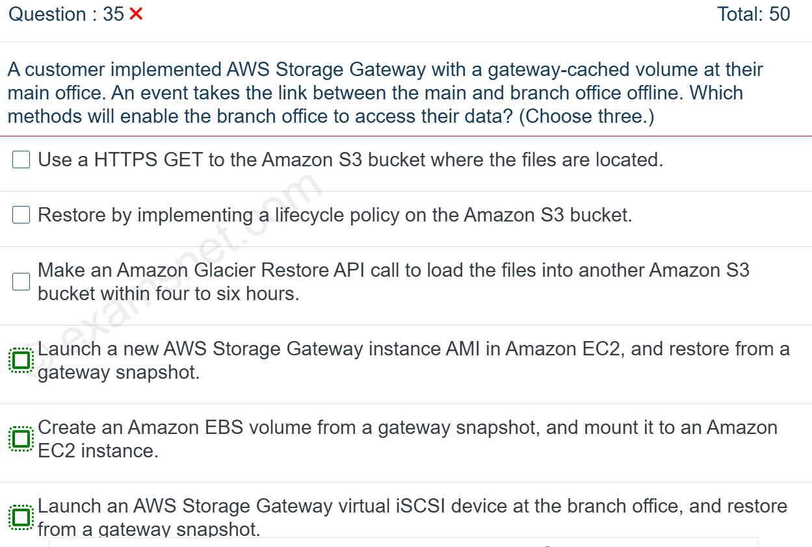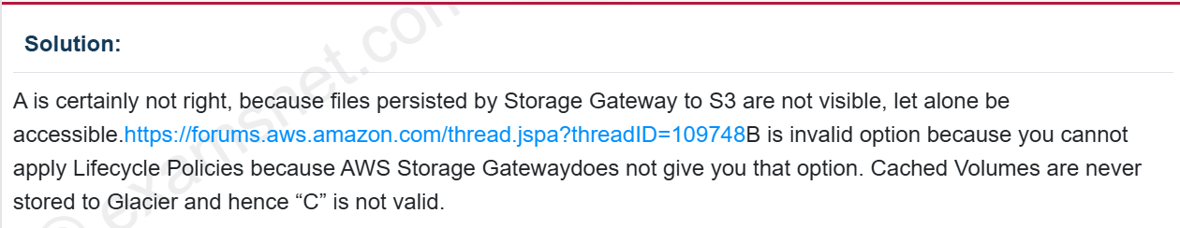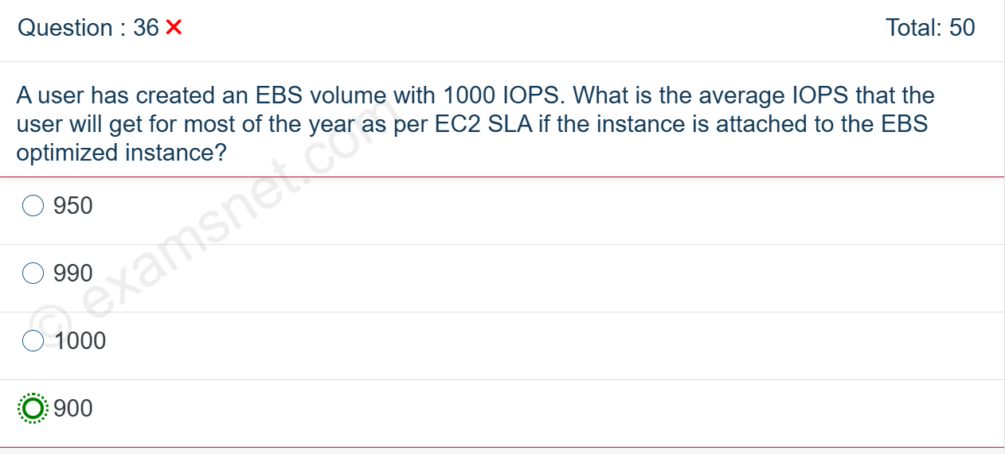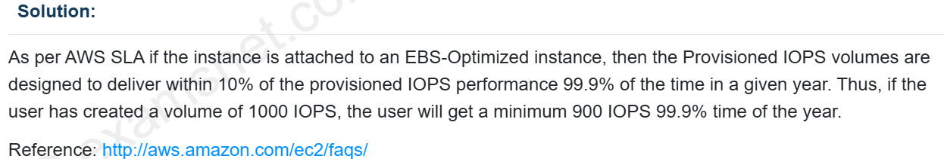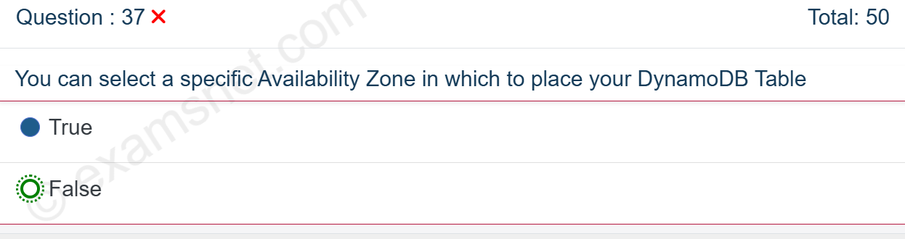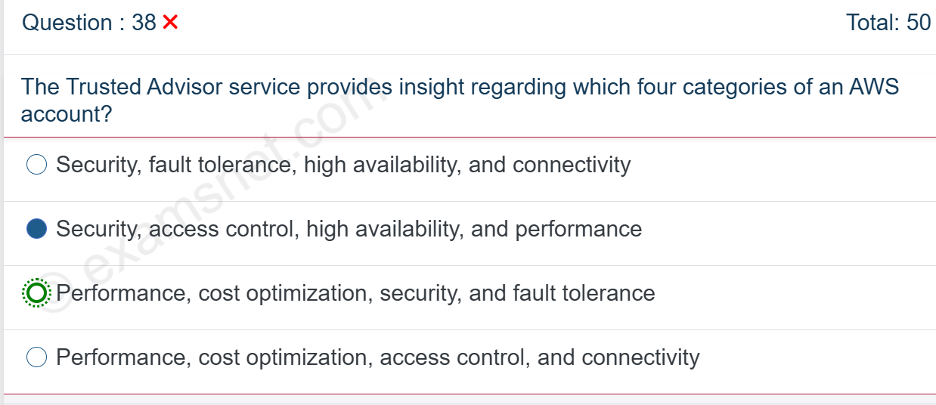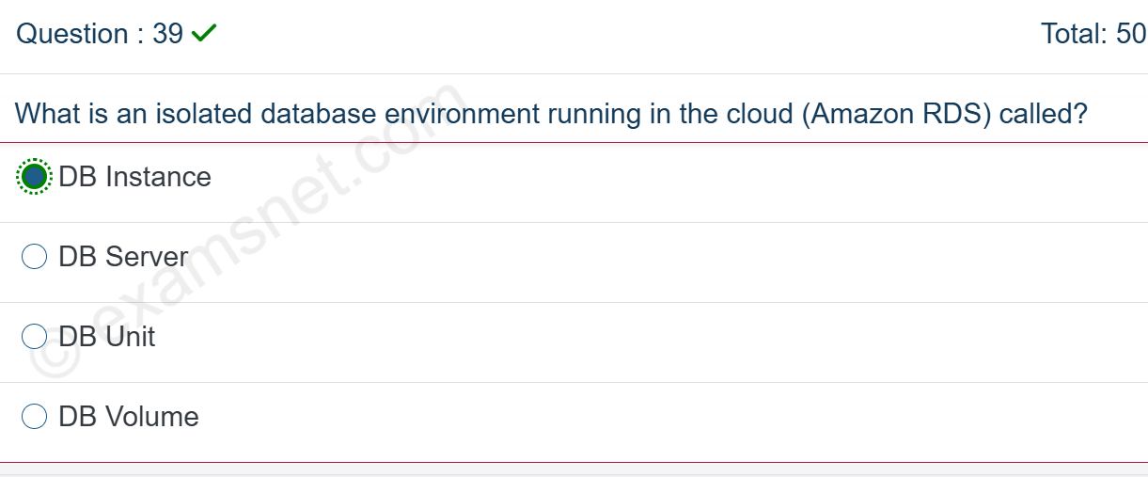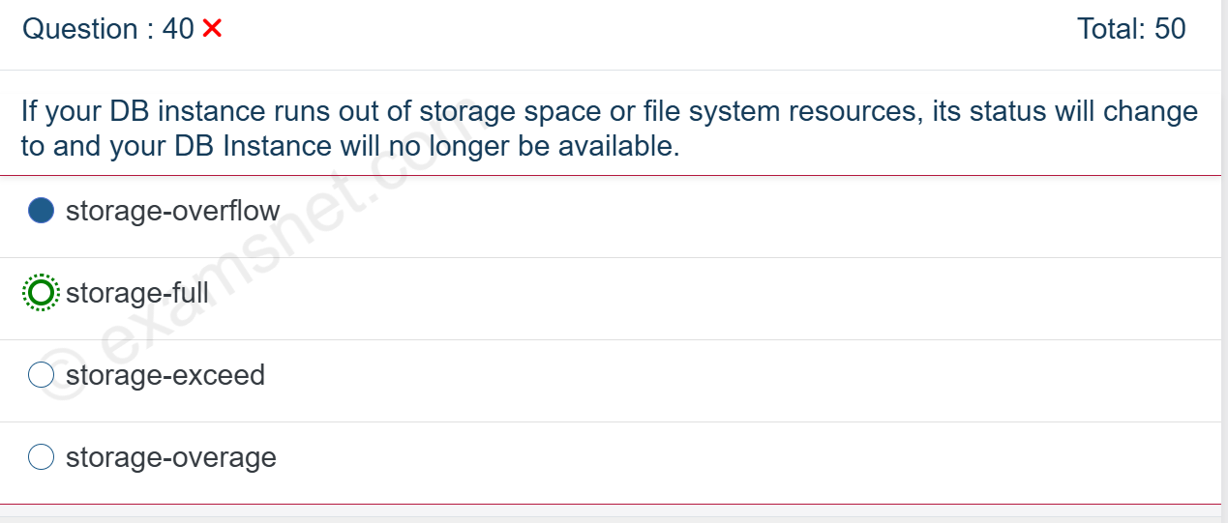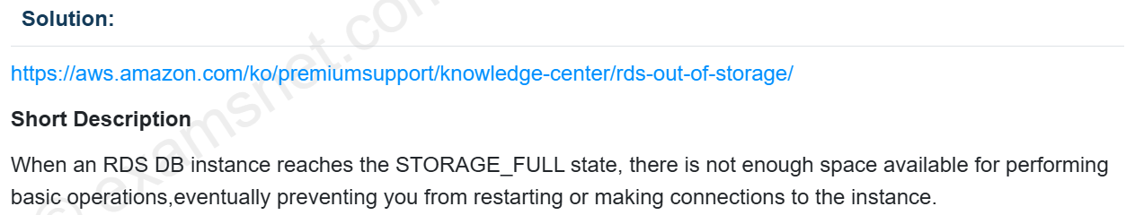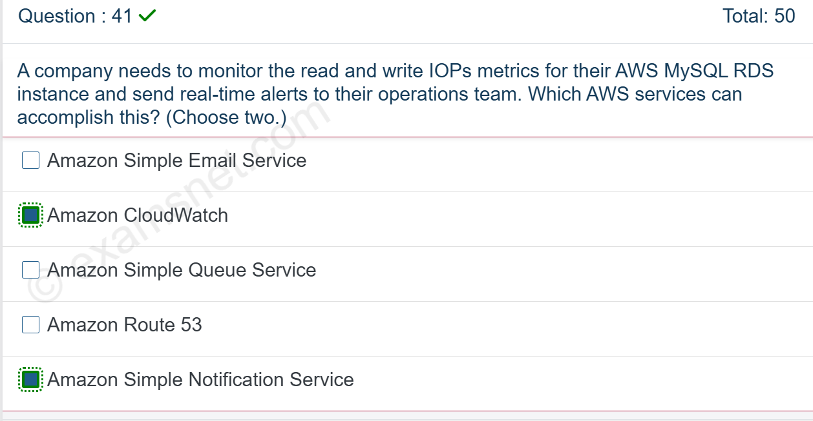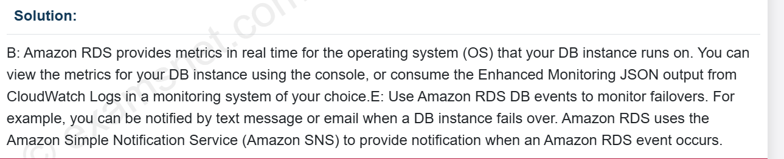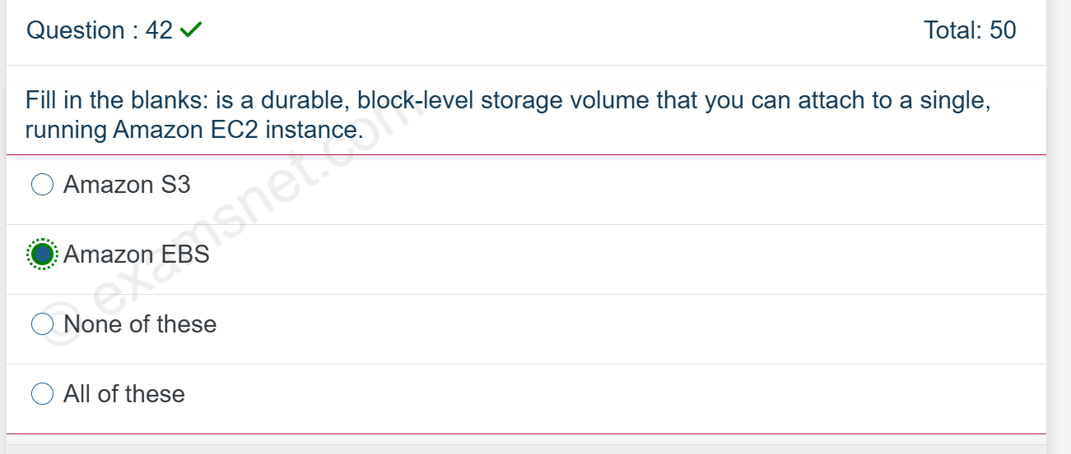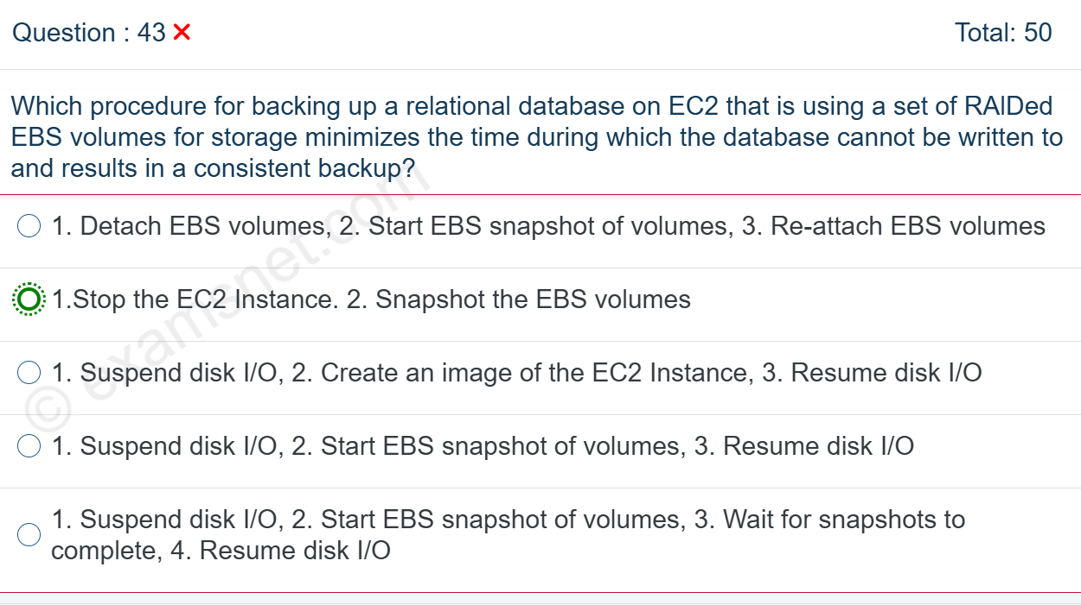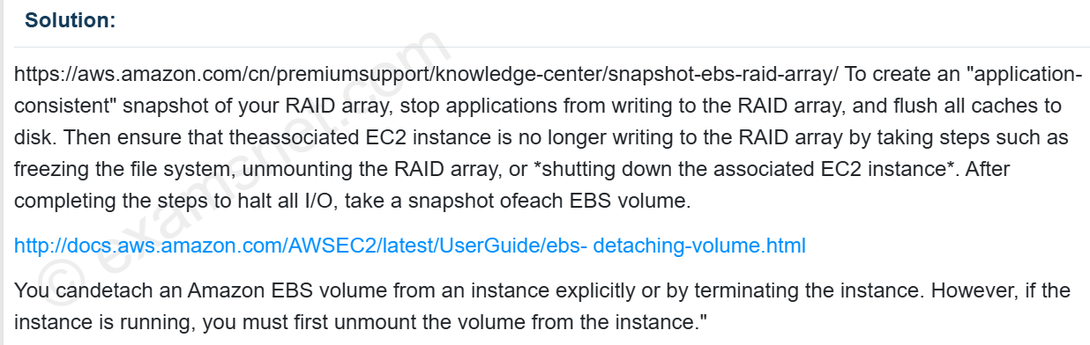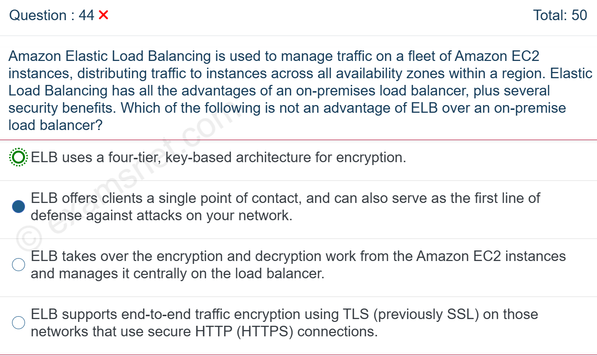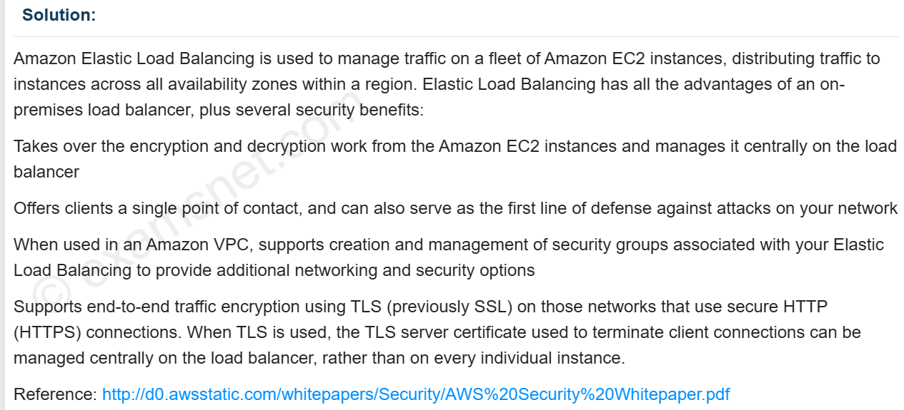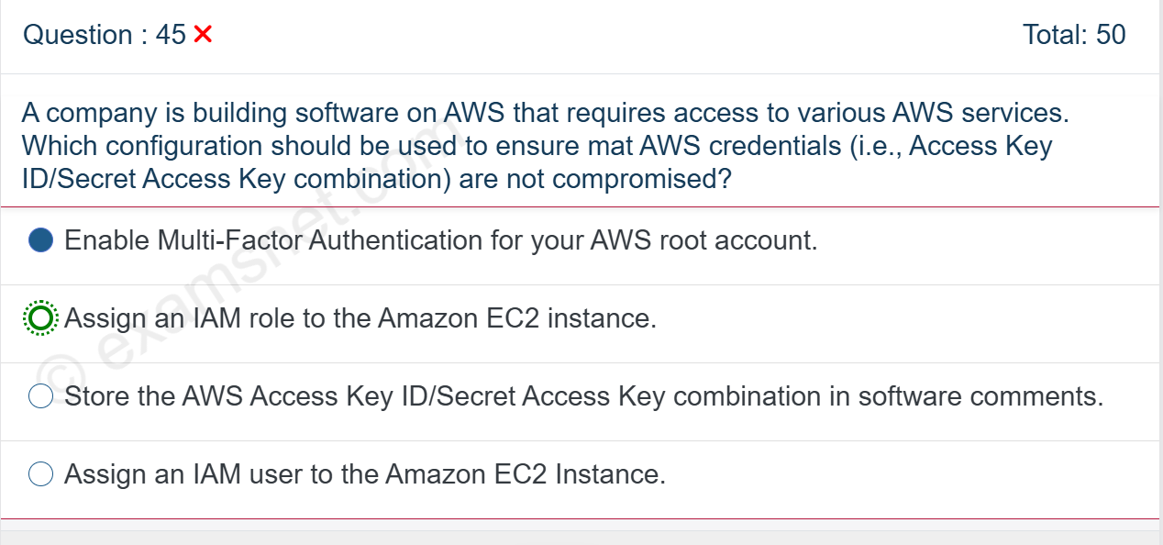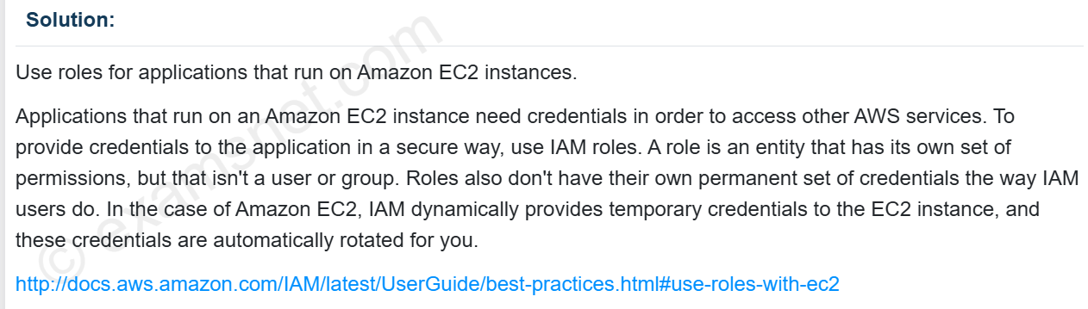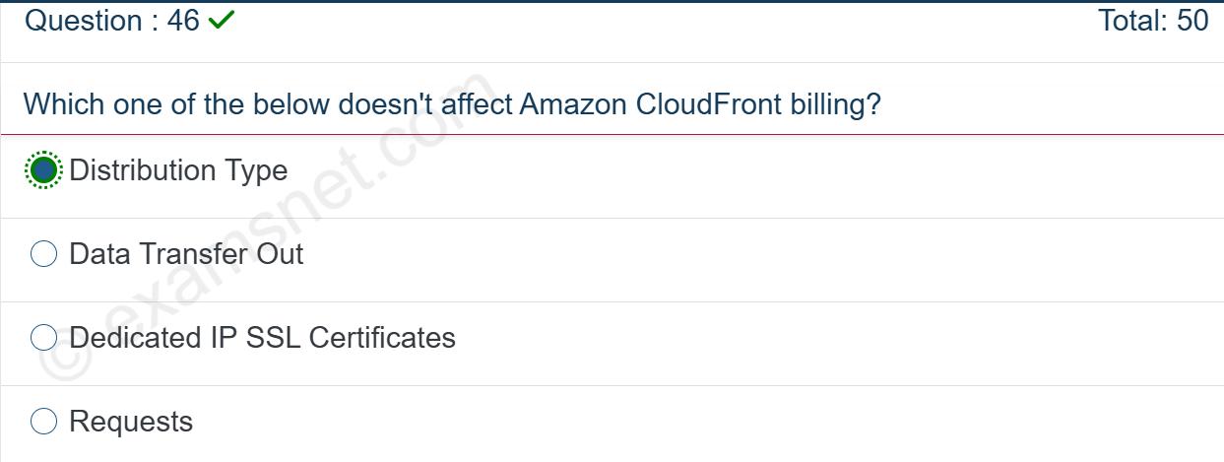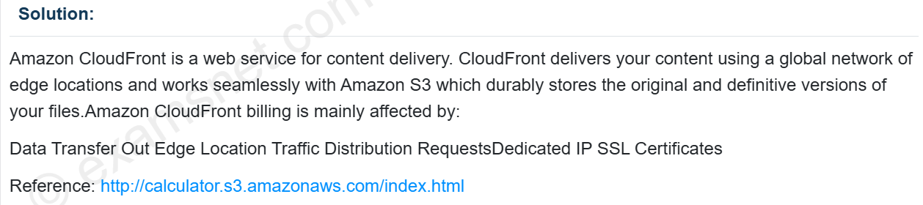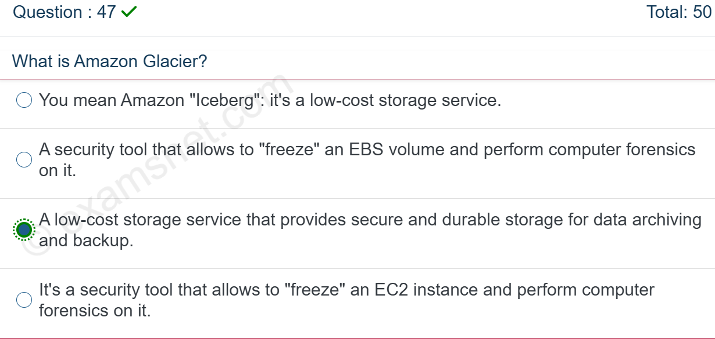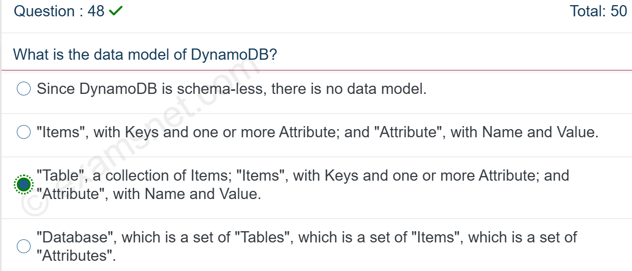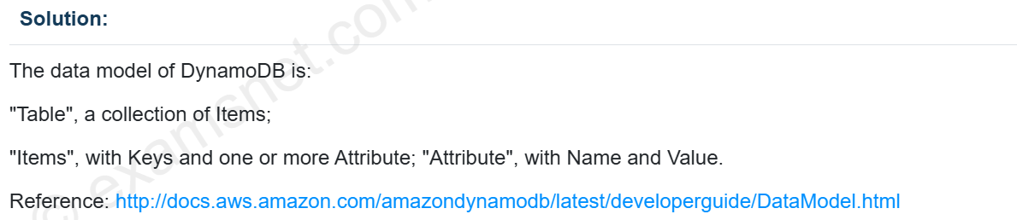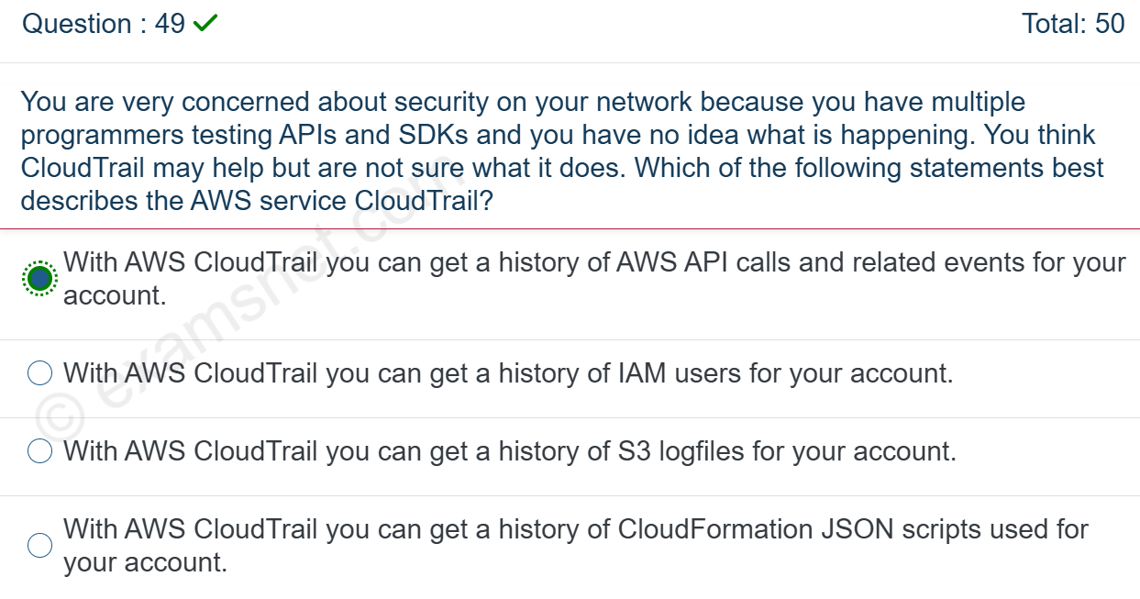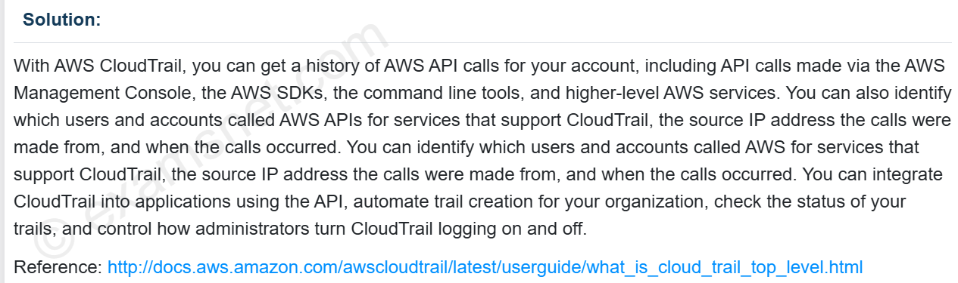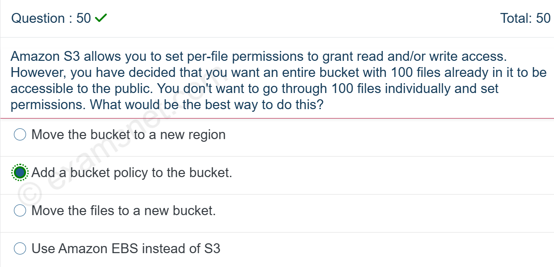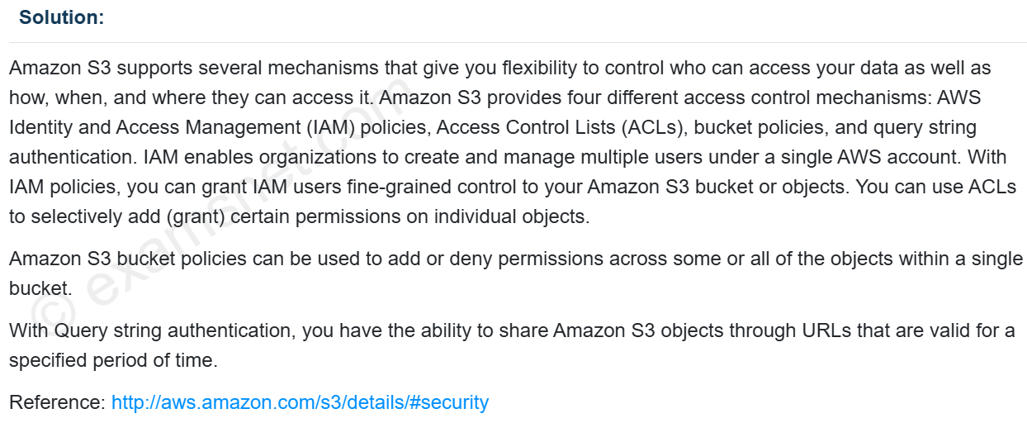

1.) Your company is planning on the following architecture for their application?

* A set of EC2 Instances hosting the web part of the application.
* A relational database for the backend.
* A Load balancer for distribution of traffic.
* A NAT gateway for routing traffic from the database server to the Internet.

Which of the following architecture ensures **high availability across all** components?

**A.** A Load balancer with one public subnet, one private subnet. The EC2 Instances placed in one Availability Zone. RDS with Multi-AZ Enabled. NAT Gateway in one availability zone.  
**B.** A Load balancer with 2 public subnets, 2 private subnets. ***The EC2 Instances placed across 2 Availability Zones***. RDS with Multi-AZ Enabled. NAT Gateways in each availability zone.  
**C.** A Load balancer with2 public subnets, 2 private subnets.The EC2 Instances are placed in 2 Availability Zones. RDS with MultiAZ Enabled. **NAT Gateway in one** availability zone.  
**D.** A Load balancer with 2 public subnets, 2 private subnets. The EC2 Instances placed in one Availability Zone. RDS with MultiAZ Enabled. NAT Gateway in one availability zone.

Correct Answer: B

For more information on Elastic Load Balancing, Multi-AZ, and NAT gateway, please refer to the below URL’s:  
[**https://docs.aws.amazon.com/elasticloadbalancing/latest/userguide/how-elastic-load-balancing-works.html**](https://docs.aws.amazon.com/elasticloadbalancing/latest/userguide/how-elastic-load-balancing-works.html) [**https://docs.aws.amazon.com/AmazonRDS/latest/UserGuide/Concepts.MultiAZ.html**](https://docs.aws.amazon.com/AmazonRDS/latest/UserGuide/Concepts.MultiAZ.html)  
**Blog Link:**  
[**https://k21academy.com/awssa20**](https://k21academy.com/awssa20)

2.) A company is planning to host an application with the below architecture.

* A lambda function that reads the metadata of objects from an **S3** bucket.
* The Lambda function then stores the metadata in DynamoDB and AWS RDS – MySQL.

Which of the following needs to be in place to ensure the above **architecture is highly available?**

**A.** Enable Cross Region Replication for the S3 bucket.  
**B.** Enable Lambda functions in Multiple Availability Zones.  
**C.** Enable Multi-AZ for the MySQL database.  
**D.** Enable Auto-Scaling for the DynamoDB table.

Correct Answer: C

**For more information, please visit the below URL:**

[**https://aws.amazon.com/lambda/features/**](https://aws.amazon.com/lambda/features/)

**Blog Link:**  
[**https://k21academy.com/awsdev16**](https://k21academy.com/awsdev16)

[**https://k21academy.com/awssa32**](https://k21academy.com/awssa32)

3.) Your company has just started using the AWS RDS service. They have an application making requests to a MySQL instance on this service. Due to the sudden surge of high requests, you need to ensure that the backup activities on the database do not interfere with the database's normal operation. Which of the following would help in this requirement?

**A.** Ensure that the underlying instance type RDS instance is using General Purpose SSD storage. This type of storage will have minimal impact on such operations.  
**B.** Ensure that the underlying instance type RDS instance is using Enhanced Networking. This type of setting will have minimal impact on such operations.  
**C.** Ensure that the Multi-AZ feature has been enabled for the underlying RDS Instance.  
**D.** Ensure that cross-region replication is enabled for the underlying RDS Instance.

Correct Answer: C

**For more information, please visit the URL below:**  
[**https://k21academy.com/awssa32**](https://k21academy.com/awssa32)

[**https://k21academy.com/awsdev14**](https://k21academy.com/awsdev14)

4.) Your company is currently hosting a long-running heavy load application on its On-premise environment. The company has developed this application in-house. Consulting companies then use this application via API calls, and each API call may take half an hour to finish. You now need to consider moving this application to AWS. Which of the following services would be best suited in the architecture design, which would also help deliver a cost-effective solution? Choose 2 answers from the options given **below.**

**A.** AWS Lambda  
**B.** AWS API Gateway  
**C.** AWS Config  
**D.** AWS EC2

Correct Answer : B and D

**For more information, please visit the URL below:**

[**https://k21academy.com/awssa31**](https://k21academy.com/awssa31)

[**https://k21academy.com/awsdev16**](https://k21academy.com/awsdev16)

[**https://k21academy.com/awssa38**](https://k21academy.com/awssa38)

DOWNLOAD NOW

5.) A mid-sized Fintech company is using AWS Organization to manage multiple AWS accounts created for each department. Each of the accounts has purchased a Reserved Instance & is running web applications on a mix of On-Demand & Reserved Instance pool. A default IAM policy is configured for all accounts. Due to high recurring costs, Management has appointed you as an AWS consultant to suggest recommendations to reduce costs. Post analysis, you suggested purchasing more Reserved Instance as compared to using On-Demand EC2 instance. How would you justify your recommendations to the management?

**A.** Use organization master account to create RI coverage budgets for all the accounts in an organization and receive SNS alert once the threshold is below 50%.  
**B.** Use Organization member account owners to create RI coverage budgets for their individual accounts in an organization & receive SNS alert once the threshold is below 50%.  
**C.** Use Organization member account owners to create RI utilization budgets for their individual accounts in an organization and receive SNS alert once the threshold is below 50%.  
**D.** Use Organization master account to create RI utilization budgets for all the accounts in an organization and receive SNS alert once the threshold is below 50%.

Correct Answer : B

**For more information, please visit the url below:**

[**https://k21academy.com/awssa18**](https://k21academy.com/awssa18)

[**https://k21academy.com/awssa19**](https://k21academy.com/awssa19)

6.) The Trusted Advisor in your AWS account raises the “Low Utilization Amazon EC2 Instances” alerts. You check the EC2 instances and find that some instances should be stopped as they are no longer used. You want to automate this process so that whenever Trusted Advisor discovers a low utilization EC2 instance, the instance will be stopped, and you will get an email notification. Which of the following methods is the most appropriate?

**A.** Use CloudFormation to create an Amazon CloudWatch Event. Register the SSM Run Command as its target to shut down the low utilization EC2 instances.

**B.** Configure Amazon CloudWatch Event and AWS Lambda to monitor the Low Utilization EC2 Instances Trusted Advisor check. Use the Lambda to stop the instances.

**C.** Create an AWS Config rule to check the Trusted Advisor Low Utilization warning status. Configure the remediation action that automatically stops the instances.

**D.**  Use CloudFormation to set up a Lambda function that gets the Low Utilization EC2 Instances status in Trusted Advisor and stops the instances. Trigger the Lambda function periodically.

Correct Answer : B

**For more information, please visit the URL below:**

[**https://k21academy.com/awssa19**](https://k21academy.com/awssa19)

[**https://k21academy.com/awssa18**](https://k21academy.com/awssa18)

[**https://aws.amazon.com/aws-cost-management/reserved-instance-reporting/**](https://aws.amazon.com/aws-cost-management/reserved-instance-reporting/)

DOWNLOAD NOW

7.) You have a set of EC2 Instances in a custom VPC. You have installed a web application and need to ensure that only HTTP and HTTPS traffic is allowed into the instance. Which of the following would you consider for this requirement?

**A.** Add a security group rule to allow HTTP and HTTPS Traffic.  
**B.** Add a security group rule to an explicit DENY all traffic and a default allow on HTTP and HTTPS Traffic.  
**C.** Add a security group rule to deny explicit traffic on HTTP and HTTPS Traffic.  
**D.** Add a security group rule to allow all traffic.

Correct Answer : A

**For more information, please refer to the below link:**

[**https://k21academy.com/awssa28**](https://k21academy.com/awssa28)

[**https://k21academy.com/awssa18**](https://k21academy.com/awssa18)

[**https://docs.aws.amazon.com/vpc/latest/userguide/VPC_SecurityGroups.html**](https://docs.aws.amazon.com/vpc/latest/userguide/VPC_SecurityGroups.html)

8.) An organization has branches across the world, and there are many applications deployed across AWS regions. As per organization compliance requirements, data in an S3 bucket should be copied to another S3

**A.** Use the S3 cp command to copy the data from one AWS region to another AWS region.  
**B.** Use Amazon S3 select to copy the data from one AWS region to another AWS region.  
**C.** Enable S3 versioning on source and destination buckets and copy the data using cross-region replication.  
**D.** Create a Lambda function in each AWS region to run AWS CLI “s3 sync” periodically to replicate data from one region to another region.

Correct Answer : C

**For more information, please refer the url below:**

[**https://k21academy.com/awssa42**](https://k21academy.com/awssa42)

[**https://k21academy.com/awssa22**](https://k21academy.com/awssa22)